

Commercial Lines

Workflows & Procedures

*For*

Acrisure NJ Partners Insurance Services, LLC



v4.22.25

Table of Contents

[EPIC BASICS 6](#_Toc196239750)

[How to Use this Document 6](#_Toc196239751)

[Epic Icons 7](#_Toc196239752)

[Home Base 8](#_Toc196239753)

[Keyboard Shortcuts 9](#_Toc196239754)

[Epic Browser 10](#_Toc196239755)

[Logging In 10](#_Toc196239756)

[Add the URL as a bookmark in the Chrome or Edge Browser 10](#_Toc196239757)

[Browser Tabs 11](#_Toc196239758)

[Connection Suite & New Functionality Popups 11](#_Toc196239759)

[Logging out of Epic 12](#_Toc196239760)

[Shutting Down Desktop 12](#_Toc196239761)

[Client Accounts 13](#_Toc196239762)

[Account Sources – REQUIRED FIELD 13](#_Toc196239763)

[Servicing Roles 14](#_Toc196239764)

[Locate Account 15](#_Toc196239765)

[Close Out of an Account Record 16](#_Toc196239766)

[Contacts 17](#_Toc196239767)

[Contacts Overview 17](#_Toc196239768)

[Add Additional Contacts 18](#_Toc196239769)

[Add Individual Contact 18](#_Toc196239770)

[Add Business – an additional entity, named insured or subsidiary 19](#_Toc196239771)

[Activities 20](#_Toc196239772)

[Home Base Open Activities 20](#_Toc196239773)

[Activity Access Levels 21](#_Toc196239774)

[Activity Workgroups 21](#_Toc196239775)

[Activity Codes 22](#_Toc196239776)

[Sticky Notes 23](#_Toc196239777)

[Email 24](#_Toc196239778)

[Microsoft Outlook Integration with Epic 24](#_Toc196239779)

[Configuring Attach to Epic Plug-In in Outlook 24](#_Toc196239780)

[Email from Distribution Manager 25](#_Toc196239781)

[Faxing 29](#_Toc196239782)

[From Distribution Manager 29](#_Toc196239783)

[Attachments 30](#_Toc196239784)

[Add Attachments and Documents by Dragging & Dropping into Epic 30](#_Toc196239785)

[Attach using Add Attachment Button located in Attachment area: 31](#_Toc196239786)

[Add Attachments and Documents using Attach to Epic Plug–In 31](#_Toc196239787)

[Attachment Access Levels 33](#_Toc196239788)

[Attachment Actions 33](#_Toc196239789)

[Finding and viewing attachments/documents 34](#_Toc196239790)

[Folders and Folder View 34](#_Toc196239791)

[Finding and viewing attachments/documents 34](#_Toc196239792)

[Create a Form Letter 35](#_Toc196239793)

[Access Filter 36](#_Toc196239794)

[Policy Basics 37](#_Toc196239795)

[Policy Sources – REQUIRED FIELD 37](#_Toc196239796)

[Policy Type Codes 38](#_Toc196239797)

[Policy Statuses 38](#_Toc196239798)

[Select the Correct Issuing Company (ICO) 39](#_Toc196239799)

[Select the Correct Broker Payable Contract 39](#_Toc196239800)

[Service Summary Rows and Stages 40](#_Toc196239801)

[Change Policy Dates 42](#_Toc196239802)

[Copy Policy 43](#_Toc196239803)

[Acord Application Prefills 44](#_Toc196239804)

[Print Application 45](#_Toc196239805)

[Service Summary Row and Stages 46](#_Toc196239806)

[Multi-Year Policies 49](#_Toc196239807)

[Continuous Policies (policies that do not expire) 50](#_Toc196239808)

[Best Practice Guide for Addresses & Contacts 51](#_Toc196239809)

[Client Addresses 51](#_Toc196239810)

[New Jersey Platform Epic Structure 52](#_Toc196239811)

[**WORKFLOWS** 54](#_Toc196239812)

[New Business Workflow 55](#_Toc196239813)

[Add New Client 56](#_Toc196239814)

[Quoting/Marketing 60](#_Toc196239815)

[Policy Received From Carrier via Email or Unrouted Attachments 65](#_Toc196239816)

[Policy Received Via Download 66](#_Toc196239817)

[Add BOR Policy 67](#_Toc196239818)

[1. Follow Add Account Workflow for new clients or if existing client locate Client Account. 67](#_Toc196239819)

[Renew Policy Workflow 68](#_Toc196239820)

[Downloaded Renewals with Incumbent No Remarketing 69](#_Toc196239821)

[Non-Downloaded Renewals with Incumbent No Remarketing 70](#_Toc196239822)

[Renewal Remarket/Rewrite Policy Workflow 71](#_Toc196239823)

[Remarketing Hand off to Marketing Team (if applicable) 71](#_Toc196239824)

[Remarket Downloaded Policies: 72](#_Toc196239825)

[Remarket Non-Downloaded policies: 74](#_Toc196239826)

[Policy Received From Carrier via Email or Unrouted Attachments 74](#_Toc196239827)

[Policy Received Via Download 75](#_Toc196239828)

[Policy Change Workflow 76](#_Toc196239829)

[Process Change/Endorsement Request (Existing Line) 77](#_Toc196239830)

[Endorsement Received from Carrier 78](#_Toc196239831)

[Process Change Request (Add Line Mid-Term) 80](#_Toc196239832)

[Endorsement Received from Carrier 80](#_Toc196239833)

[Process Audit 82](#_Toc196239834)

[Policy Extension Change Policy Dates 83](#_Toc196239835)

[Cancel Policy Workflow 84](#_Toc196239836)

[Cancel Policy - Insured Request incl Lost on BOR 85](#_Toc196239837)

[Signed LPR Received: 85](#_Toc196239838)

[Cancellation Confirmation Received from Carrier: 86](#_Toc196239839)

[Cancel Downloaded Renewal Line after Rewrite of Expiring Term 86](#_Toc196239840)

[Cancel a Policy Line from a Package Mid-Term 87](#_Toc196239841)

[Cancel Confirmation Received from Carrier: 87](#_Toc196239842)

[Notice of Cancellation for Non-Payment of Direct Bill incl. Premium Financing 89](#_Toc196239843)

[Policy Not Renewed Workflow 91](#_Toc196239844)

[Mark Policy as Not Renewed 91](#_Toc196239845)

[Policy Reinstated Workflow 92](#_Toc196239846)

[Reinstate Policy 92](#_Toc196239847)

[Claims Workflow 94](#_Toc196239848)

[Add New Claim 95](#_Toc196239849)

[Claim Updates: 95](#_Toc196239850)

[Close Claim when carrier has closed the claim: 95](#_Toc196239851)

[Client Contracts/Services Workflow 96](#_Toc196239852)

[JOB AIDS 98](#_Toc196239853)

[JA.1 Marketing Module Lite (New or Renewal Business) 99](#_Toc196239854)

[Add Master Marketing Submission 99](#_Toc196239855)

[Add QNEW (New Business) or QREW (Renewal) Activity 101](#_Toc196239856)

[Send Applications to Carriers 101](#_Toc196239857)

[Carrier Responses Received 102](#_Toc196239858)

[Carrier Selected for Binding 102](#_Toc196239859)

[Policy Received from Carrier 106](#_Toc196239860)

[JA.2 Marketing Module (Full Version) 107](#_Toc196239861)

[Add Master Marketing Submission 107](#_Toc196239862)

[Create Carrier Submission 107](#_Toc196239863)

[Submit to Carriers 108](#_Toc196239864)

[Create Carrier Response 108](#_Toc196239865)

[Attach Quote-Related Documents to SCAS Activity 108](#_Toc196239866)

[Bind/Accept Quote 109](#_Toc196239867)

[Move Marketed Lines to Current Policies 109](#_Toc196239868)

[JA.3 Accounting Processes 110](#_Toc196239869)

[JA.4 Renewal Manager 111](#_Toc196239870)

[Renewal Stages 111](#_Toc196239871)

[Renewal Events 111](#_Toc196239872)

[Renewal Manager Workflows 113](#_Toc196239873)

[JA.5 Proofs of Insurance in Epic 115](#_Toc196239874)

[Auto ID Cards 115](#_Toc196239875)

[JA.6 CSR24 Workflow 116](#_Toc196239876)

[JA.7 DocuSign Integration 117](#_Toc196239877)

[JA.8 Import and Export Risks 121](#_Toc196239878)

[STEP 1: Create a Mapping File 121](#_Toc196239879)

[STEP 2: Enter data on the Mapping File 122](#_Toc196239880)

[Exporting Risks out of Epic 122](#_Toc196239881)

[Importing Risks into Epic 122](#_Toc196239882)

[Import Errors 124](#_Toc196239883)

[JA.9 Creating a Proposal or Summary in Epic 125](#_Toc196239884)

[General Information 125](#_Toc196239885)

[How to Generate a Proposal 126](#_Toc196239886)

[JA 10: Epic Proofs of Insurance 129](#_Toc196239887)

[Certificate Processing in Epic 129](#_Toc196239888)

[EPIC Binder 138](#_Toc196239889)

[JA. 11 Job Aid – Statement of Values 140](#_Toc196239890)

[Update Subjects of Insurance 141](#_Toc196239891)

[Prepare Statement of Values 142](#_Toc196239892)

[Print Statement of Values 143](#_Toc196239893)

# EPIC BASICS

## How to Use this Document

This document contains valuable information relevant to your usage of EPIC, including **Epic Basics**, day-to-day **Workflows**, and **Job Aids. DO NOT PRINT THIS DOCUMENT.**

For optimal usage:

* Click the **View** menu at the top in the Microsoft Word toolbar.
* Checkmark **Navigation Pane**

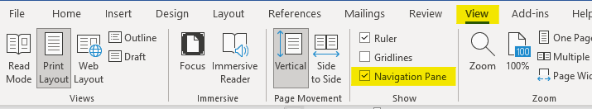

* The left pane will open and show a listing of topics.

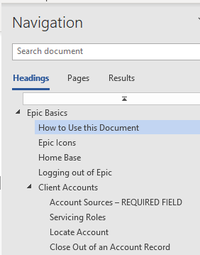

* Click on the topic to jump to that section/page.
* You will also find hyperlinks within the document that will take you to a specific page or Job Aid.

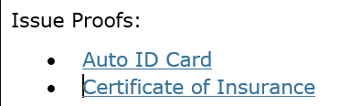

* Some hyperlinks will take you to a webpage outside of the document.

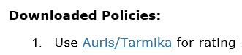

## Epic Icons

|  |  |  |  |
| --- | --- | --- | --- |
|  | Add New |  | Change column width |
|  | Edit |  | To define a search |
|  | Print list view |  | Executes search. These are cumulative. To begin a new search, click “Clear Filter” |
|  | Sortable column – ascending/descending |  | The logout button will close all open windows. If any screen requires validation (the process isn’t complete), the screen with display prior to closing |
|  | Change the order of items | **RIGHT CLICK** | Right clicking from a selected will often generate the same menu as ACTIONS. |
|  | Collapses and opens sections of screen or moves full list from one screen to another |  | Click on the Paperclip to attach documents saved in Epic (Email) |
|  | Required Field – must complete |  | Click on the File to attach files saved on a local or network drive (Email) |
|  | Desired Field – agency would like field completed |  | Contacts in EPIC (from email) |
|  | Customize columns displayed in the list view |  | Contacts in Outlook (from email) |

## Home Base

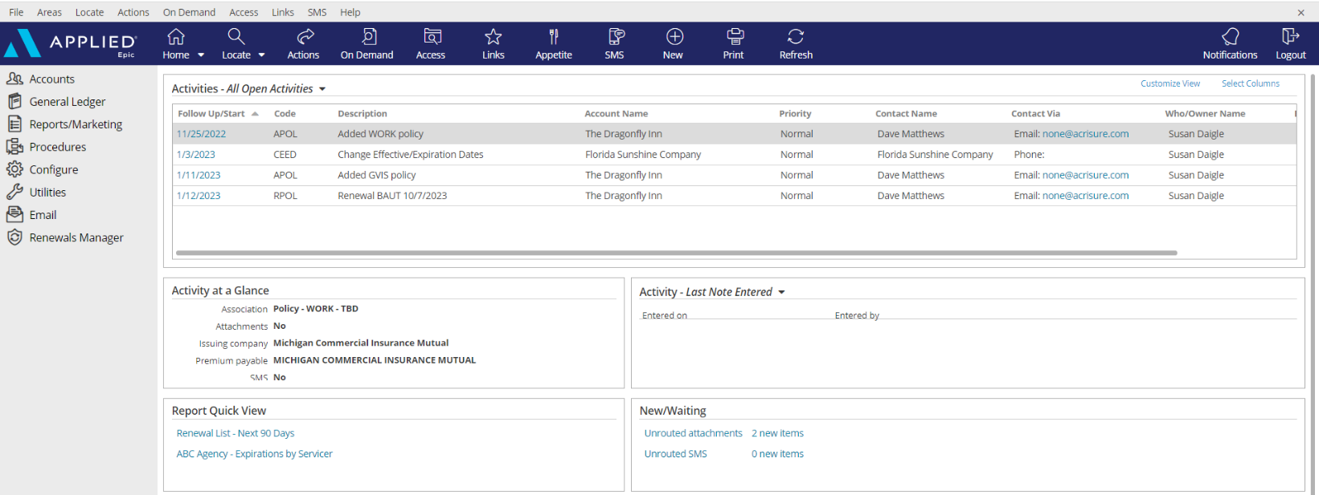

|  |
| --- |
| 1. **Open Activities** (suspense, follow up, to-do list)    * Use “Select Columns” to add columns to your view.    * You can also change the position of the columns by clicking and dragging the column headers to move them.    * Sort columns in ascending or descending order by clicking on the column header. 2. **Activity at a Glance** – displays information about the highlighted activity. 3. **Activity Tasks** OR **Last Note Entered** – if you are assigned a task within an activity the task will appear here only if the activity above, associated with the task, is highlighted. You can change the view from “Activity – Tasks” to “Last Note Entered” by clicking the dropdown arrow and selecting that option. 4. **Report Quick View** – Created reports can be sent to Report Quick View for easy access. Just click the link and the report will open. Data displayed is in real time and will be refreshed as of the date it is opened. 5. **New/Waiting** – If your agency has opted to use Front End Scanning, your scanned mail can be accessed by clicking the “Unrouted Attachments” link. The number of items in your “inbox” will also display. 6. **Navigation Panel** – Items listed will direct you to different parts of Epic or the client’s account if you are on the locate screen or within the client account. Items listed change depending on which screen you’re on. This is known as the “View” panel. 7. **Blue Options Bar** – Each icon contains action options, which change depending on which screen you’re on. Think of this as the “Do” bar. 8. **Log Out button** – Clicking this button will close all the open screens/windows and log you out of Epic. 9. **Locate** – Click the dropdown arrow to see list of last 20 accounts accessed |

## Keyboard Shortcuts

|  |
| --- |
|  |

## Epic Browser

### Logging In

|  |
| --- |
| 1. Open a web browser.    1. Chrome    2. Edge 2. Enter URL:    1. Production/Live: <https://acris03.appliedepic.com/#/>    2. Test/Training: [https://ve061t1web.appliedepic.com/#/](https://ve061t1web.appliedepic.com/%23/) |

### Add the URL as a bookmark in the Chrome or Edge Browser

|  |  |  |
| --- | --- | --- |
| 1. In the browser URL address field, enter <https://acris03.appliedepic.com/#/>; press the keyboard enter key. 2. Add to Bookmarks/Favorites as follows:  |  |  | | --- | --- | | **CHROME**    Click the star icon  Enter a name for the bookmark; click Done | **EDGE**    Click the star icon  Enter name and add to Favorites Bar; click Done | |

### Browser Tabs

|  |
| --- |
| Browser tabs will open at the top when accounts are located and selected.    Use browser tools like Tab Grouping and Zoom, if desired.  To prevent connection issues, close out of a client by clicking the X above the Logout button, NOT the x in the browser tab |

### Connection Suite & New Functionality Popups

|  |
| --- |
| The Connection Suite is required to ensure full functionality and connection within Epic Browser. Acrisure, IT manages all updates in the background for the Connection Suite Plugin. **Ignore these popups.** If you are receiving an error, follow the instructions to [hard shutdown](#_Logging_out_of) to ensure there’s a clean connection to all services run on your computer. If you are experiencing functionality issues after shutting down, submit a ticket to [support@acrisure.com](mailto:support@acrisure.com).  ***Reminder: A hard shut down of your computer should be done at the end of each workday.*** |

### Logging out of Epic

|  |
| --- |
| **\*\*IMPORTANT\*\***  Whenever you **close out of Epic,** be sure to click the LOGOUT button at the top right in the blue Options Bar. Do not X out or Epic will not close properly and may cause issues when signing in again.  **NO** |

### Shutting Down Desktop

|  |  |  |  |  |  |  |
| --- | --- | --- | --- | --- | --- | --- |
| **\*\*IMPORTANT\*\***  Log out of Epic and SHUT DOWN your computer **at the end of each workday.**   |  |  | | --- | --- | | Shut down the computer by clicking the Start Menu in the bottom left-hand corner of your desktop |  | | Click Power |  | | Click Shut Down |  | |

## Client Accounts

### Account Sources – REQUIRED FIELD

|  |  |
| --- | --- |
| 0. Cross Sell-Platform | 3. Marketing - Other |
| 1. AM/AE Solicited | 3. Marketing - Social Media |
| 1. Producer Solicited | 3. Marketing - Telemarketing |
| 2. Referral - Acrisure Cyber Services | 3. Marketing - Tradeshow |
| 2. Referral - Acrisure Global Network | 4. Other/Unknown |
| 2. Referral - Acrisure Title Partner | 5. Win Back |
| 2. Referral - Association | 6. Call In/Walk In |
| 2. Referral - Broker - Acrisure | 7. Campaign - Encompass CC |
| 2. Referral - Broker - Non-Acrisure | Z. Update Needed |
| 2. Referral - Carrier | **Account Source is a Required Field.**  **Be sure to select the appropriate one for tracking and reporting purposes.**  If you do not know the policy source, select “**Update Needed**” so it can be updated when known. |
| 2. Referral - Client |
| 2. Referral - Employee |
| 2. Referral - Evolution Advisors |
| 2. Referral - FBC Mortgage |
| 2. Referral - Family Office |
| 2. Referral - Financial Partner/WM |
| 2. Referral - Franchisor |
| 2. Referral - GA |
| 2. Referral - Loan Officer |
| 2. Referral - Other |
| 2. Referral - Payroll Firm |
| 2. Referral - Realtor |
| 2. Referral - TPA |
| 3. Marketing - Acrisure.com |
| 3. Marketing - Internet Search |

**For more details as how to use each source code, refer to the Epic Source Codes cheat sheet found on the** [**NJ Platform SharePoint.**](https://acrisure.sharepoint.com/:x:/r/sites/AcriWorld/Shared%20Documents/Enterprise_Solutions_Center/Platforms/New_Jersey/Epic,%20CSR24%20%26%20Indio%20Resources/Epic%20-%20P%26C/Job%20Aids,%20Quick%20Reference%20Guides%20%26%20Cheat%20Sheets/Guide%20-%20Epic%20Source%20Codes,%20v12.2024.xlsx?d=w9345929321794014bf793163b41662f8&csf=1&web=1&e=O8nHWk)

### Servicing Roles

|  |  |  |  |  |  |  |  |
| --- | --- | --- | --- | --- | --- | --- | --- |
| External Service Team | |  | | --- | | Acrisure Service Center | | Carrier Service Center | | GA - Emerson Reid | | GA - Martin Insurance Services \* | | GA - PGM \* | | GA - Suvaun \* |   **When an account and/or policy is managed by an external service team (the Acrisure Service Center, a Carrier Service Center, or a General Agent on the EB side), select the appropriate one from the drop-down list.**  **Note:**  **An Acrisure-owned GA will be indicated by an asterisk.** |
| Marketing |
| P&C Producer 1 (Primary) |
| P&C Producer 2 (Servicing) |
| P&C Servicer 1 (AM) |
| P&C Servicer 2 |
| P&C Claims |
| P&C Account Executive |
| Surety Producer |
| Surety Servicer |
| EB Producer 1 (Primary) |
| EB Producer 2 (Servicing) |
| EB Servicer 1 (AM) |
| EB Servicer 2 |
| EB Account Executive |
| Non-Insurance Producer |
| Non-Insurance Servicer |
| CRM Relationship Manager |
| Contract Producer/Consultant |
| Contract Servicer |

### Locate Account

|  |
| --- |
| * Click the **Locate** button to **search** for existing clients.   **Locate Options:**   * + **Account/Business Name** – *contains* anywhere in the account detail name field and business contact.   + **Claims: Additional Party** – by involvement type, name, or phone number   + **Insurer Claim#** - must be exact & complete.   + **Internal Claim#** - must be exact & complete.   + **Date of Loss** – *range*   + **Last name, first name** – *begins with* and will search account detail name field and individual contacts.   + **Lookup Code** – *begins with*   + **Phone Number** – must be exact & complete.   + **Policy #** - *begins with*   + **Prior Account ID** – *begins with* (from your prior system)   + **Relationship** – relationship type and then account name.   + **Sanction Search Reference #**   + **Submission ID** – *begins with* (in marketing)   + **Vehicle Registration Number** * Click the **Locate** button to **add new** client accounts. * Click the **drop-down arrow** on the Locate button to access the last 20 accounts accessed (including client accounts, employee accounts, company accounts, etc.) |

### Close Out of an Account Record

|  |
| --- |
| Locating and selecting an account will create a new tab in the browser. **Close the account record by clicking the X above the Logout button** NOT by clicking the x within the tab at the top. |

## Contacts

### Contacts Overview

|  |  |
| --- | --- |
| **Individual Contact** | This is an additional individual contact (person) on the account. By choosing an individual contact additional fields are available, such as date of birth, SSN, marital status, driver's license number, etc. Be sure to click the lock to the right of the PII fields. |
| **Primary Contact** | This is an **individual contact** and should be selected as the primary contact for the account. To make a contact **Primary,** click **ACTIONS** **> Change Primary Contact**. The Primary Contact is displayed in the Rolodex Card on the bottom left corner in the client’s account. |
| **Category** | Contacts are categorized based on their relationship to the Account: Contact Only—Policy Only—Both Contact & Policy |
| **Description** | **Be sure to add Description** is used to best represent the position or role of the contact (i.e., owner, manager, etc.) Select the appropriate description(s) for each Contact. These are used for tracking and reporting. |
| **Classifications** | **Be sure to select** the appropriate contact classification. DM=Decision Maker; PC=Primary Contact   |  |  |  | | --- | --- | --- | | \_\_User - Benefits Technology | \_Personal (DM) | Property Manager | | \_\_User - Compliance Dashboard | \_Personal (PC) | Trustee | | \_\_User - CSR24/Portal | \_Risk Management (PC) |  | | \_\_User - Indio | \_Safety (PC) | | \_Certificates | \_Surety (DM) | | \_Commercial (DM) | \_Surety (PC) | | \_Commercial (PC) | \_Work Comp (DM) | | \_Cyber (DM) | \_Work Comp (PC) | | \_Cyber (PC) | 401k Owner | | \_EB (DM) | 401K Payroll | | \_EB (PC) | 401k Plan Administrator | | \_EB Compliance | CARD | | \_EB Eligibility Contact | Del Ray | | \_EB HRLS Compliance Summit | HR Insider | | \_EB Plan Admin | Investment News | | \_HR Leader | PL Broker | |

## Add Additional Contacts

### Add Individual Contact

|  |
| --- |
| 1. From the client’s account, click **Contacts** in the left panel. 2. Click the **ADD** button.      1. Select the **Individual** radio button. 2. Enter First Name, Last Name 3. **Category:** Indicate whether contact only, policy only, or both contact & policy 4. **Description:** Select the appropriate description for this contact 5. Enter the address. If the account address is the same as the contact address, check the box for Use Account Address 6. Enter phone number (indicate if mobile) and email address - ***NOTE: Email is a required field***. If the contact does not have an email address, enter [none@acrisure.com](mailto:none@none.com)      1. Click **DETAIL** to add additional information such as date of birth, SSN, personal info, etc.   If not, click **FINISH**. |

### Add Business – an additional entity, named insured or subsidiary

|  |
| --- |
| 1. Click **Contacts** from the Navigation Panel (left) and add Business contacts as needed. 2. ***NOTE: Email is a required field***. If the contact does not have an email address, enter [none@acrisure.com](mailto:none@none.com) 3. Click **Detail**  * **TAB: Business Contact** * Contact info = enter phone numbers; set Contact Methods for default in other areas * Business Info = Business type, NAICS and SIC, Company revenue, payroll, payroll cycle * Identification numbers = FEIN, SSN, etc. |

## Activities

|  |
| --- |
| Activities in Epic perform three essential functions:   * Add a record to the client file that an action was performed. * Allow a follow up or Open Activity to remind you to do something at a current or future date. * Permanently document the file with the use of Notes within Activities   ***NOTE: Activities or Notes in an Activity cannot be moved to another account*** |

### Home Base Open Activities

|  |  |
| --- | --- |
| **Select Columns** | Check or uncheck the columns you wish to see in your Home Base view. |
| **Customize View** | Allows the addition of other Employee’s activities to reflect within your own open activities list (if given permission) |
| **Right Click to Manage** | * **Close Activity** – *follow up action is completed.* * **Add Note** – *add notes related to the process that is still pending.* * **Add Task** – *assign a portion of the activity process to someone else to work on* * **Change Follow-up Date/Time** – *if the deadline for completing the activity can be moved.* * **Change Who/Owner** – *reassign the activity for someone else to take care of, which will move to their Home Base* * **View All Notes** – *Read all notes related to a specific activity process.* * **Take Ownership** – *If the activity is assigned to another person or a work group, you can reassign the activity to yourself.*   ***Note: you can multi-select activities (CTRL + Click) and perform the above actions to multiple activities at the same time*** |

### Activity Access Levels

|  |  |  |  |  |  |  |  |  |  |
| --- | --- | --- | --- | --- | --- | --- | --- | --- | --- |
| |  | | --- | | **Description** | | Accounting | | Financial Services | | HIPAA | | HR Consulting | | NJIIF | | NJUEP | | Polaris | | TPA | |

### Activity Workgroups

|  |  |  |  |  |  |  |  |  |  |  |  |  |  |  |  |  |  |  |  |  |  |  |  |  |  |  |  |  |  |  |  |  |  |  |  |  |
| --- | --- | --- | --- | --- | --- | --- | --- | --- | --- | --- | --- | --- | --- | --- | --- | --- | --- | --- | --- | --- | --- | --- | --- | --- | --- | --- | --- | --- | --- | --- | --- | --- | --- | --- | --- | --- |
| |  |  | | --- | --- | | Code | Description | | @APPAY | Applied Pay Default Work Group | | @EXT | External Default Group | | @LEADS | Leads Inbox Default Work Group | | ACCT | Accounting | | APAY | Accounting - Payables | | ARVW | Accounting Review | | CIDT | ACRISURE Centralized Interface Download Team | | DBSC | Direct Bill Service Center | | INVO | Invoicing | | PRBR | Accounting - Pr/Br | | RSP1 | Certificate Team - SFG | | RSP2 | P&C Inhouse Processing team - SFG | | RSP3 | P&C- Resource Pro Processing Team - SFG | | RSP4 | P&C Resource Pro - Dedicated Team | | RSP5 | P&C In-house Endorsement - SFG | | RSPP | ResourcePro Policy Insight Checking Team | | SA | Systems Analyst | |

### Activity Codes

|  |
| --- |
| Activity codes lists are located in the [Manual, System + Download Activity Cheat Sheet](https://acrisure.sharepoint.com/:x:/r/sites/AcriWorld/Shared%20Documents/Enterprise_Solutions_Center/Platforms/New_Jersey/Epic,%20CSR24%20%26%20Indio%20Resources/Epic%20-%20P%26C/Job%20Aids,%20Quick%20Reference%20Guides%20%26%20Cheat%20Sheets/Guide%20-%20Manual,%20System%20+%20Download%20Activity%20Cheat%20Sheet%20v5.7.25.xlsx?d=w9f39a04793e8484082a83a8e2ed64708&csf=1&web=1&e=GWFoDS)  . They are organized into 1 spreadsheet with 1 workbook for each and can be filtered and sorted. |

## Sticky Notes

|  |
| --- |
| You can add a sticky note to an area of an account (e.g., a client's contact area or detail for an employee), a specific item on the account (e.g., a policy, binder, or claim), or an area in the program (e.g., claims reports or unrouted attachments). The note displays when the area is accessed. |

|  |
| --- |
| 1. From your client’s options bar, click **New.** 2. Click **Sticky Note** 3. Enter note details.   **Helpful notes:**   1. Click the **Double Right Arrows,** to collapse note. 2. Click the **Three Vertical Dots**, to manage sticky note. 3. Click **X**, to delete sticky note. 4. Click **+**, to add a new sticky note. |

## Email

### Microsoft Outlook Integration with Epic

#### Set Outlook Email Integration Default

|  |
| --- |
| ***Setting Outlook as the Email Integration Option will allow the launch of Outlook from Epic. Emails sent from Epic will automatically attach to the client’s account and will also add a Sent Item in Outlook.***  ***This integration applies to emailing from Attachments or from any of the blue email links within a client’s account. This does NOT apply to the Distribution Manager.***   1. From the Home Base, click **Configure** from the left Navigation Panel 2. Click **User Options** and select **Email.** 3. Select the Outlook radio button.      1. Click **Finish.** |

### Configuring Attach to Epic Plug-In in Outlook

|  |
| --- |
| 1. Open Microsoft Outlook 2. Find **Attach to Epic** in the ribbon and click the down arrow next to the word **Applied.**      1. Select Browser 2. Enter the Applied Epic Browser URL 3. Choose a Default Browser      1. X out of this window |

### Email from Distribution Manager

#### Set up Distribution Manager Email Account

|  |
| --- |
| 1. From the **Home Base**, click **Configure** from the left Navigation Panel 2. Click **User Options** and select **Distribution Email Accounts** 3. If more than one account is listed, **delete all except Primary Email Account**      1. Highlight Email Account and click the **Edit** pencil. 2. Enter the Distribution Email Details as follows.    * Associated Agency = select your Agency from the dropdown list    * Display Name = enter your full name    * Reply address = enter your email address 3. Mail Server Settings    * Check the box to Use external mail server.    * Enter your email address. 4. Click **Finish**   **NOTE: For those whose legal entity name is being retained (Public Entity, Financial Services, etc.) it is important NOT to use the Acrisure email address; use your legal entity’s email address.** |

#### Set up Distribution Email Signature

|  |
| --- |
| 1. From **Outlook**, copy your email signature (Right Click/Copy or CTRL+C) 2. Go back to Epic. 3. From the **Home Base**, click **Configure** from the left Navigation Panel 4. Click **User Options** and select **Distribution Email Accounts** 5. With your DMS email account highlighted, click the edit pencil. 6. Click the **Email Signature** tab.      1. Click the **Add** button (+) 2. Enter a **Description** for your signature and check the **Default** box.      1. In the white space below the format buttons, paste the email signature which was copied in Step 1 above (Right Click/Paste or CTRL+V)   ***If Acrisure Logo does not paste appropriately follow the steps below:***   1. Right click your Acrisure logo from your email signature inside of outlook and click Save as picture.      1. Go back into Epic, Click to Highlight box where logo should appear. 2. Select Insert/Edit Image Button 3. Search for Logo saved to your computer.      1. Once Logo is selected click Open, then Click blue Ok button. 2. Resize Acrisure logo as needed. 3. Click **Finish** 4. The email signature will now be listed.      1. Click **Finish**. |

#### Send Email from Distribution Manager

|  |  |
| --- | --- |
| As part of the normal workflow, when the ACORD form is ready to print/send, utilize the **Distribution Manager** to send documents.   1. From the **Distribution** Tab, set delivery option to **Email.** 2. The **From** field defaults to your email address, however the sender can be changed. 3. Add **Signature** (should default) 4. Add more than one recipient, cc, or bcc. 5. Enter body of the email with full HTML functionality (change font size/color, add logos, pictures, change alignment, etc. 6. If the documents need to be sent to multiple recipients, Click on **“To”** Button      1. Contact Address Book will open. Double click on the Contact Name to add as an additional recipient. Once all additional recipients are added, click **Finish.** |  |

## Faxing

### From Distribution Manager

|  |
| --- |
| As part of the normal workflow, when you are ready to print/send an ACORD form, you can use the **Distribution Manager** to send documents.   1. From the **Distribution** Tab, set delivery option to **email.** 2. Select a “**From**” email address. 3. In the “**To**” field, type **fax= [**the fax number (including the 1)] @**efaxds.com.** 4. Enter **Subject** line (required) 5. Enter message, if needed      1. Click **FINISH** to send. |

## Attachments

|  |
| --- |
| Attachments help you manage related information and documents for an account in a single location. Regularly attaching important files and email messages to the relevant areas of an account provides transparency and ensures that this information is easy to find even for users who are less familiar with the account. For example, attaching email correspondence to an account makes it easy to find in the system so you do not have to search a mailbox outside of the client’s account for it.  **Best Practices:**   * Click & drag emails, any policy documents, signed applications, supplemental forms, and any other “busy work” onto the Activity related to the process you are working on. * Be sure to include the added step of selecting the [**policy folder**](#_Folders_and_Folder) so the access button can be used to filter all related final policy documents and further filter by the policy folder, so you only see the PDF documents.   **Please follow the** [**NJ Region Attachment Naming Conventions**](https://acrisure.sharepoint.com/:x:/r/sites/AcriWorld/Shared%20Documents/Enterprise_Solutions_Center/Platforms/New_Jersey/Epic,%20CSR24%20%26%20Indio%20Resources/Epic%20-%20P%26C/Job%20Aids,%20Quick%20Reference%20Guides%20%26%20Cheat%20Sheets/Guide%20-%20P%26C%20Naming%20Conventions,%20v6-6-2024.xlsx?d=wdd211a7a4bb24aa297e76c02b86752e0&csf=1&web=1&e=Rwp33M) **when adding an Attachment.** |

### Add Attachments and Documents by Dragging & Dropping into Epic

|  |
| --- |
| 1. Drag & Drop from Outlook, Network folder, or Desktop into Epic 2. Attach all Documentation to the corresponding ACTIVITY.   **NOTE: When creating initial activity, it is Best Practice to attach Activity to the Policy level. If there is no Policy when Activity is created, attach Activity to the Account level.** |

### Attach using Add Attachment Button located in Attachment area:

|  |
| --- |
| 1. From your client’s navigation panel, click **Attachments.** 2. Click **Add (+)**    1. **Document**: 3. Click **Continue** 4. To **[Create a Form Letter](#_Create_a_Form)**    1. **Existing File:** 5. Click **Continue** 6. Click **Continue** 7. Click **Browse** 8. Click **Choose Files** 9. Double click your file to choose. 10. Click **OK** 11. Click **Finish**     1. **eForm:** 12. Check the applicable eForm. 13. Click **Continue** 14. **Type**, select applicable Type from the drop down. 15. Click **Finish** |

**Add Attachments and Documents using Attach to Epic Plug–In**

|  |
| --- |
| **Attaching New Email Using Attach to Epic Plug-In**   1. Click **NEW Email** Button in Outlook 2. Checkbox Attach to Epic Box 3. Add Client Email Address in the To Field, Type Title in Subject Line and Type out body of email. When finished with email and all relevant documents are attached, click **SEND**. 4. Attach To Tab will open in Browser. 5. Click Magnifying Glass to the right of the Code Field to Locate Client. Click **Finish** Once Account is found. 6. Under Attach To – Identify and select the appropriate dropdown (Policy or Activity) for where the Email and/or documents should be attached to. 7. Once all required fields are completed, Click **Finish** and email will be routed into Applied.   **Attaching Existing Email Using Attach to Epic Plug-In**   1. Right Click on existing email in Outlook and select Attach to Epic 2. Attach to Tab will open in Browser. 3. Click Magnifying Glass to the right of the Code Field to Locate Client. Click **Finish** Once Account is found. 4. Uncheck the **“Delete original after attaching”** box.   **NOTE: If this box does not get un-checked, your email will be deleted from your outlook.**     1. Under Attach To – Identify and select the appropriate dropdown (Policy or Activity) for where the Email and/or documents should be attached to. Once all required fields are completed, Click **Finish** and email will be routed into Applied. |

### Attachment Access Levels

|  |  |  |  |  |  |  |  |  |  |  |  |  |  |  |  |  |  |  |  |  |  |  |
| --- | --- | --- | --- | --- | --- | --- | --- | --- | --- | --- | --- | --- | --- | --- | --- | --- | --- | --- | --- | --- | --- | --- |
| Access levels allow restriction of access to attachments by granting security rights to certain groups.  The default Access Level = Public   |  |  | | --- | --- | | **Access Level** | **Description** | | 1 | HIPAA | | 2 | Accounting | | 3 | Financial Services | | 4 | Client Financials | | 5 | HR Consulting | | 6 | Polaris | | 7 | NJIIF | | 8 | NJUEP | | 9 | TPA | | 10 | W9 | |

### Attachment Actions

|  |  |
| --- | --- |
| Click **ACTIONS** | * **Convert to PDF** – *Converts any document to PDF format in two clicks; can also combine multiple documents into one PDF document.* * **Distribute Attachments** – *Uses Distribution Manager to email documents to client contacts.* * **Edit Attachment Detail** – *Edit description, association, access levels, and folder.* * **Move Attachment** – *Move attachment to another account, folder, etc.* * Policy Checking (Do Not Use) * **Reactivate Attachment** – *Used to remove an attachment from the Inactive area.* * **Send via CSIO eDelivery –** NOT APPLICABLE * **Send to eSignature** – *Launches DocuSign* * **Send Via Email** – *Emails attachment through Outlook* |

### Finding and viewing attachments/documents

|  |
| --- |
| * **Important Policy Documents:** In the attachments list view, click the link “Show Only Important Policy Documents” to view all documents you have marked as “Important”   To revert to all documents, click “Show All Documents.” The link does the filtering for you.     * **Filters: Choose** a filter: Ex. Attached within last 18 months. To see all attachments: Ex. Attached Date within range 1/1/1900 through Open.   You can also filter by multiple Types of Business and save the filter default. |

### Folders and Folder View

|  |
| --- |
| Please refer to the [**NJ Region Folder Structure Guide**](https://acrisure.sharepoint.com/:x:/r/sites/AcriWorld/Shared%20Documents/Enterprise_Solutions_Center/Platforms/New_Jersey/Epic,%20CSR24%20%26%20Indio%20Resources/Epic%20-%20P%26C/Job%20Aids,%20Quick%20Reference%20Guides%20%26%20Cheat%20Sheets/Guide%20-%20Epic%20Folder%20Structure%20v5.7.25.xlsx?d=w7b9a5d0dec5c48d0a8368022c4fcb4dc&csf=1&web=1&e=1CW2CY) . |

### Finding and viewing attachments/documents

|  |
| --- |
| * **Important Policy Documents:** In the attachments list view, click the link “Show Only Important Policy Documents” to view all documents being previously marked as “Important”   To revert to all documents, click “Show All Documents.” This link serves as a filtering tool.     * **Filters:** Choose a filter: Ex. Attached within last 6 months.     Filtering by multiple Types of Business is also an option and can be set as the filter default. |

### Create a Form Letter

|  |
| --- |
| To select a form letter:   1. Click the Attachments area in the Client account. 2. Click the ADD button (+) 3. Select Document – click Continue.      1. Select a Template Folder 2. Select the form letter from the dropdown list.      1. Under the Contact tab, check the recipient of the letter. 2. Click the Policy/Claim tab and select a policy or claim to reference in the letter.      1. Click **Continue** 2. Change attachment description if needed. 3. Click **FINISH** 4. Epic data will merge with Microsoft Word and letter will open. 5. Update letter as needed. When finished, click the X at the top right to close the Word document. 6. Click YES to save document as an attachment. 7. The Attachment will be saved in WORD format; however, if you are sending the letter via email or to eSignature, be sure to Convert to PDF first, as follows:    1. Right Click on the WORD attachment    2. Select “Convert to PDF”    3. Click FINISH 8. From the attachments area, find the PDF version of the form letter, right click and either “Send to eSignature” for DocuSign, or “Send Via Email” to send from Outlook. 9. If “Send Via Email” an attachment screen will pop up. You can change the description for the email attachment if needed. |

### Access Filter

|  |
| --- |
| The Access button will filter items for a specific policy, activity, transaction, within the **Client’s Account Example:**   1. From the policy screen, select a **policy.** 2. Click the **Access** button. 3. Select an option:    * **Activities** = displays all the activities associated with the selected policy    * **Attachments** = displays all the attachments associated with the selected policy    * **Claims** = displays all the claims associated with the selected policy    * **Opportunities** = displays all the sales opportunities associated with the selected policy    * **Services** = displays all the services associated with the selected policy    * **Proofs** = displays all the Proofs associated with the selected policy    * **Transactions** = displays all the transactions associated with the selected policy    * **Auditing** = displays all the documents a client has access to via the CSR24 Portal    * **Notifications** = displays notifications related to the selected policy   **Note: Use the Access button to filter attachments, Example: Highlight policy, Access/Attachments, and only the attachments associated with the policy will appear.** |

## Policy Basics

### Policy Sources – REQUIRED FIELD

|  |  |
| --- | --- |
| 0. Cross Sell-Platform | 3. Marketing - Social Media |
| 1. AM/AE Solicited | 3. Marketing - Telemarketing |
| 1. Producer Solicited | 3. Marketing - Tradeshow |
| 2. Referral - Acrisure Cyber Services | 4. Other/Unknown |
| 2. Referral - Acrisure Global Network | 5. Win Back |
| 2. Referral - Acrisure Title Partner | 6. Call In/Walk In |
| 2. Referral - Association | 7. Campaign - Encompass CC |
| 2. Referral - Broker - Acrisure | Z. Update Needed |
| 2. Referral - Broker - Non-Acrisure | 2. Referral - Carrier |
| 2. Referral - Client | **Account Source is a Required Field.**  **Be sure to select the appropriate one for tracking and reporting purposes.**  If you do not know the policy source, select “**Update Needed**” so it can be updated when known. |
| 2. Referral - Employee |
| 2. Referral - Evolution Advisors |
| 2. Referral - Family Office |
| 2. Referral - FBC Mortgage |
| 2. Referral - Financial Partner/WM |
| 2. Referral - Franchisor |
| 2. Referral - GA |
| 2. Referral - Loan Officer |
| 2. Referral - Other |
| 2. Referral - Payroll Firm |
| 2. Referral - Realtor |
| 2. Referral - TPA |
| 3. Marketing - Acrisure.com |
| 3. Marketing - Internet Search |
| 3. Marketing - Other |

### Policy Type Codes

|  |
| --- |
| **To reference a full list of P&C Policy types available in Epic, refer to the** [**Epic Policy Types Guide**](https://acrisure.sharepoint.com/:x:/r/sites/AcriWorld/Shared%20Documents/Enterprise_Solutions_Center/Platforms/New_Jersey/Epic,%20CSR24%20%26%20Indio%20Resources/Epic%20-%20P%26C/Job%20Aids,%20Quick%20Reference%20Guides%20%26%20Cheat%20Sheets/Guide%20-%20Epic%20Policy%20Types,%20v5.8.25.xlsx?d=w38a01234796f437a84481ddae77f191e&csf=1&web=1&e=w9jrKP) |

### Policy Statuses

|  |  |  |
| --- | --- | --- |
| **CODE** | **DESCRIPTION** | **WHEN USED** |
| **NEW** | New | New policy |
| **NBR** | New - BOR | New policy acquired via BOR |
| **CNW** | Cancelled (New) | Cancelled policy when original policy status was NEW |
| **CRN** | Cancelled (Renewal) | Cancelled policy when original policy status was REN |
| **CRW** | Cancelled – Rewritten (Flat or Mid-Term Rewrite) | Cancelled from original carrier and rewritten with another carrier |
| **X-N** | Not-Renewed (New) | Policy went to term but did not renew – original status = NEW  **(Carrier Non-Renews or client does not renew)** |
| **X-R** | Not-Renewed (Renewal) | Policy went to term but did not renew – original status = REN  **(Carrier Non-Renews or client does not renew)** |
| **XNW** | Shared New | Shared New |
| **XRW** | Shared Renewal | Shared Renewal |
| **REN** | Renewal | Renewed policy with same carrier |
| **REW** | Renewal – Rewrite (First Renewal w/ New Carrier) | Policy rewritten with another carrier on renewal |
| **ZER** | Created In Error | Use when deprecating policy for conversion cleanup, etc. |
| **ZIN** | Info Only | Use for Info Only policies which are not active with any carrier |

### Select the Correct Issuing Company (ICO)

|  |
| --- |
| **When setting up a policy, it is critical that the correct writing/issuing company be selected. This selection will pre-fill the correct Billing Company (PPE (Premium Payable Entity)).** |

### Select the Correct Broker Payable Contract

|  |
| --- |
| * **If the PPE is a Broker,** change the Premium Payable CA to BR and select the Broker from the dropdown list. * Select the correct Payable Contract by clicking the dropdown arrow. * **This step is critical to align accurate Accounting functions.** |

### Service Summary Rows and Stages

|  |
| --- |
| Service Summary Rows **(SSR)** provide a chronological order of services provided to the account. Each service/action taken to a policy will be reflected in the service summary row in the order of most recent.  When viewing a policy in Epic it is essential to view the most recent Service Summary Row.  From the policy view screen in a client account click to highlight the policy. Once doing so the most recent Service Summary Row will highlight. To view a different service summary row, click to highlight.  **For example**: Service Summary #2 *will* display the policy details for the endorsement effective on the date noted on the Service Summary row. While Service Summary Row #1 *will not* reflect the added vehicle since Service Summary row #1 is the details of the policy when the policy term began.    **NOTE: When viewing a multi-line package, highlight one of the lines under the policy header to view the Service Summary Row. The screenshot below indicates if CPK1 is selected, there are no SSR’s displayed.**    **Single click on a line of business then the most recent Service Summary Row will default.**  **See below.** |

### Change Policy Dates

|  |  |  |
| --- | --- | --- |
| **SYSTEM GENERATED ACTIVITY** | | |
| Change Effective/Expiration Dates | **CEED** | # Change Effective/Expiration Dates |

|  |
| --- |
| 1. Click your Policy. 2. From the options bar, click **Actions.** 3. Click **Change Effective/Expiration Dates** 4. Click **Yes** 5. Verify/Update, **RED** is required: 6. Change effective date to 7. Change expiration date to 8. Change row effective date to, **all service summary row effective dates must fall within the policy term**. 9. Click **Finish** 10. **Activity**, **RED** is required: 11. **Code**, **CEED –** system generated activity for changing effective/expiration date. 12. **Who/Owner** 13. **Follow up/Start.** 14. **Status**, activity should remain Open until receipt of policy. 15. **Notes** 16. **Status**, activity should default to Closed, Successful 17. **Notes** 18. Click **Finish** |

### Copy Policy

|  |
| --- |
| To reduce the time you spend manually reentering information when you write a piece of new business similar to an existing policy or split or merge business on one or more accounts, you can use the **Copy Policy**action to copy application and Servicing/Billing information to the same client, a new client, or from a prospect to a client.  **Note: This action does not copy attachments, transactions, activities, claims, Proofs of Insurance, or Service Summary information.** |

|  |
| --- |
| 1. Click your Policy, the policy needing to be copied. 2. From the options bar, click **Actions.** 3. Click **Copy Policy** 4. From Copy Policy, verify/update, **RED** is required: 5. **Destination** 6. **Structure** 7. **Policy Detail** 8. **Lines of Business** 9. **Line Commission** 10. Click **Detail** 11. Policy has now been copied, from the navigation panel verify/update: 12. **Servicing/Billing** 13. **Commercial AP** 14. Line of Business details 15. From the navigation panel, click **X.**   7. Click either:   1. **No, leave “In Process”**, to leave application “open” to edit.   Click **Finish**   1. **Yes, perform action,** select **Submit Application** from the drop down to generate the Acord for distribution.   Click **Finish**  **Submit Application:**  **Detail** tab, verify/update if applicable.  **Forms/Attachments** tab, add/remove attachments & forms if needed.  **Organization Contact**, verify.  **Distribution**, select to email, fax, print.  Click **Download & Print**, to preview.  Click **Finish**  **Yes, perform action,** select **Update Stage to Submitted** from the drop down.  Click F**inish** |

### Acord Application Prefills

|  |
| --- |
| Prefilled ACORD applications will be configured by your platform system administration for your convenience.   * Use prefills to enter common information or agency standard limits/coverages. * The prefill can then be added when the policy is created by clicking the dropdown list and selecting the prefill.      * Prefills can also be added while in the application (navigation panel is open to the policy form), then clicking Actions / Select Prefill. Service Summary Stage must be In Process. |

### Print Application

|  |
| --- |
| 1. Click your Policy. 2. From the options bar, click **Actions.** 3. Click Review **Application** 4. Verify/Update **Distribution** tab:   **Attach Without Distributing**  **Email**: [**Send Email from Distribution Manager**](#_Send_Email_from)  **Fax**: [**From Distribution Manager**](#_From_Distribution_Manager)  **Print**:  For a **print preview**, click **Download & Print**  To **save a copy in Attachments**, select **Print** from the Via dropdown, click **Finish**. From there you can email directly out of attachments via a right click on your PDF and selecting **“Send via Email”** to link to your Outlook. |

### Service Summary Row and Stages

|  |
| --- |
| Service Summary Rows are very important in Epic as these represent the chronological order of services provided to a policy. Each service/action taken to a policy will be reflected in the service summary row in order of most recent, usually. When viewing a policy in Epic it will usually default to the most recent service summary row, but it important to be aware of what service summary row you are viewing.  From the policy view screen in a client account, highlight the policy and make note of the SSR. Each SSR represents the policy details at that point in the policy term. For the example below: SSR#2 will display the policy details for the endorsement effective on the date noted on the SSR. SSR line #1 will not reflect the added vehicle, since the first SSR is the new/renew details at the effective date.    NOTE: when viewing a multi-line package, highlight one of the lines under the policy header to view the Service Summary Row. In the screen shot below, the CPK1 is selected but there are not any SSR’s displayed.    Single click on a line of business and the Service Summary Rows will be displayed, see below.    Having multiple service summary rows to view allows us to be able to see the policy details at any given date during the term. To compare the changes made between one service summary row and another, from the tool bar, go to **ON Demand>Service Summary Comparison**  The list below explains what the different stages represent. The stages reflect the actions taken in EPIC and are not always reflective of the status chosen in the policy details. It is always important to make sure that the status of the policy is representative of the current stage of the policy details.   * **In Process** – Policy details are not complete, and the application is open for edits. * **Submitted** – it has been sent to the carrier for action and the application or endorsement is now locked down. * **Issued** - policy or endorsement has been issued by the carrier or confirmation of coverage received from carrier. * **Not Issued** – Use only if policy or endorsement has not been issued by the carrier and it was previously in submitted stage. * **Cancelled** – Cancellation has been confirmed by the carrier.   **Migrated** – one time use for conversion and simulates the stage of submitted |

### Multi-Year Policies

|  |
| --- |
| * The way multi-year policies are set up in Epic is dependent on when premium is billed/collected. * If premium is collected at policy inception for the entire policy term add the policy with an expiration date showing the true end of the policy term.   *Example: Jane Smith has a three-year Liability policy. The carrier is collecting the full premium at the policy inception. You are billing the client for the full three-year premium.* *Policy would be entered with an effective/expiration date of January 1, 2020, to January 1, 2023.*   * If premium is collected EACH YEAR on a multi-year policy, add the policy with a one year effective/expiration date. At the end of the first year, renew the policy and bill the second-year premium. You would continue to renew the policy until the end of the policy term.   *Example: Michael Jones has a three-year Liability policy. The carrier is collecting a third of the premium for the first year, a third of the premium for the second year, and a third of the premium for the third year. The policy would be entered into Epic as an annual term (i.e., January 1, 2020, to January 1, 2021). At the end of the first year, the policy would be RENEWED, and* *the second third of the premium would be billed.* *Policy would need to be renewed each year for three consecutive years.* |

### Continuous Policies (policies that do not expire)

|  |
| --- |
| * **Personal & Commercial Policies**:   + If an Agency Bill or Direct Bill policy and expiration date is known, enter as reflected on policy or binding documents.   + If a true continuous policy (i.e., E&O, Tail Coverage, etc.) where expiration date is not known and policy changes are not expected, enter the expiration date as 9999.   + If policy changes are expected, enter policy as an annual term and renew from year to year until coverage ends. * **Individual Life & Health & Employee Benefits Policies:**   + If expiration date is known, enter as reflected on policy or binding documents/service contract.   + If expiration date is not known, enter expiration date with a 9999 year. * **Client Contracts/Fee Policy Types:**   + If a service contract/fee policy type and expiration date is known, enter expiration date as reflected on service contract.   + If a service contract/fee policy type and expiration date is not known, enter expiration date as a one-year term and renew annually until the contract is cancelled.   + This process would be continued until the carrier is no longer collecting annual premiums or is cancelled. |

## Best Practice Guide for Addresses & Contacts

***Contact information is an important part of the Client Account record. Please follow these guidelines to keep the data clean.***

### Client Addresses

|  |
| --- |
| * **First Address Line**: Enter street address only – No PO Box, No Names or DBAs   + DO NOT add P.O. Box numbers; Add P.O. Box information as a separate contact using the L-Mailing description.   + It is okay to include Suite Number, Apartment Number, Floor Number with the street address.        * + **DO NOT INCLUDE DBA NAME OR NAME OF INSURED CONTACT IN THE FIRST LINE OF THE ADDRESS FIELD. See proper instructions on adding a** [**DBA**](#_Add_Business_Contact) **and a** [**Contact**](#_Add_Individual_Contact)**.** * **Be sure to enter City, State & Zip Code** * **Address validation tools** are used in Epic Browser and in AcriVision mapping and will create errors if the street address is not shown on the first line. * **Add a Contact and Address Description:**   + Contact – Named Insured   + Address – Primary Physical Address * **Additional Mailing or Billing addresses** can be set up as Contacts – do not forget to add address and Contact descriptions such as DBA, L-Billing, or Post office Box. |

## New Jersey Platform Epic Structure

|  |  |  |
| --- | --- | --- |
| **AGENCIES** | | |
| 1NJ | Acrisure NJ Partners Insurance Services, LLC | |
| ANJ | Chadler Investment Advisory Solutions, LLC | |
| BGR | Acrisure NJ Partners Risk Management Solutions, LLC | |
| MAC | Acrisure, LLC dba MacLean Insurance Agency | |
| RPI | Acrisure, LLC dba Robert P. Petri and Daughter Insurance Agency | |
| **BRANCHES** | | |
| 1NJ | Acrisure NJ Partners Insurance Services, LLC | |
| ANJ | Chadler Investment Advisory Solutions, LLC | |
| BEC | Beckerman & Company | |
| BEV | Bob Evans Agency | |
| BGR | BRM Claims Administrators | |
| BRM | Balken Risk Management | |
| CNS | Cornerstone Insurance Group | |
| CWD | Coastwide Insurance Associates | |
| DNJ | Doyle Alliance Group | |
| GDB | George Dawli Book of Business | |
| HOB | Henry O. Baker Insurance Group | |
| HRP | Hughes Recreational Products | |
| IDA | Independent Distributor Alliance | |
| IMA | IMAC Insurance Agency | |
| LES | Leading Edge Safety and Health | |
| MAC | MacLean Insurance Agency | |
| MBN | Monarch Benefit Advisors | |
| NAI | NAIMC | |
| PEA | Public Entity Advocates | |
| POL | Polaris Galaxy Group | |
| RIG | Reliance Insurance Group | |
| RPI | Robert Petri & Daughter | |
| SAN | Sanford Insurance Group | |
| SFG | Scirocco Financial Group | |
| STF | The Stratford Financial Group | |
| SUB | Suburban General Insurance Agency | |
| TRU | The True Agency LLC | |
| WFS | Wall Financial | |
| GIL | Gilsenan Agency Book of Business | |
| JBG | JB Greco & Associates | |
| FOR | Fortitude Insurance Group | |
| **DEPARTMENTS** | | |
| ACT | Accounting | |
| BEL | Benefits - Large (Eligible Lives of 100+) | |
| BEM | Benefits - Middle (Eligible Lives 20-99) | |
| BES | Benefits - Small (Eligible Lives 2-19) | |
| BND | Bonds | |
| CLL | Commercial - Large (2.5K+ Revenue) | |
| CLM | Commercial - Middle (1k-2.5K Revenue) | |
| CLS | Commercial - Small (<1k Revenue) | |
| FNS | Financial Services | |
| ILF | Individual Life & Health | |
| PEL | Personal Lines - Large (1K+ Revenue) | |
| PEM | Personal Lines - Middle (250-1K Revenue) | |
| PES | Personal Lines - Small (<250 Revenue) | |
| REF | Non-Insurance Referrals | |
| SRV | Services | |
| TPA | TPA | |
| **PROFIT CENTERS** | | |
| ACT | Accounting |  |
| BEN | Benefits |  |
| BND | Bonds |  |
| CND | Commercial Condo |  |
| COM | Commercial |  |
| COR | CORE | Core Business – Use when no other profit center applies |
| CPG | Construction Practice Group |  |
| DAT | Distressed Auto |  |
| EEA | PL Employee Account | Use for Employees who have their personal insurance business with Acrisure (account will be locked down) |
| FNS | Financial Services |  |
| HNW | PL High Net Worth | Smaller accounts with high-valued property ($2M+) |
| ILF | Individual Life & Health |  |
| MAF | PL Mass Affluent | Well-rounded accounts with high-valued property ($2M), domestic workers, etc. |
| MED | Medicare |  |
| MML | Med Mal Practice Group |  |
| PER | Personal Lines |  |
| PLB | Personal - Brokered | Formerly CCW-Coastal Program |
| PLP | A & E Practice Group |  |
| PUB | Public Entity |  |
| REF | Non-Insurance Referrals |  |
| REG | Real Estate Group |  |
| RMG | Risk Management Services |  |
| TPA | TPA |  |
| XSC | Acrisure Service Center | **Home Office Use Only** |

**WORKFLOWS**



## New Business Workflow

**The following lists represent activities that might be part of the New Business process. Individual user results may vary and not all new business processes will require the use of all these system generated and/or manual activities.**

|  |  |  |
| --- | --- | --- |
| **SYSTEM GENERATED/ACTION ACTIVITIES** | | |
| Add Account | ADD1 | Adding account that is already bound business |
| Add Account | ADD2 | Adding account that is a prospect and not bound business |
| Add Policy | APOL | Adding a policy |
| Add Policy by BOR | BORP | Adding a policy brought in by BOR |
| New Marketing Submission | AMMK | Activity for tracking marketing when using Master Marketing or Master Marketing Lite |
| ACTIONS > Submit to Carriers | SCAS | This activity generates when you use Action>Submit to Carrier. If not using Marketing Lite, use one SCAS per carrier submission. |
| **MANUAL GENERATED ACTIVITES** | | |
| Acrisure Real Estate Services Referral | GACR | Use this to track new business being referred from/to the Acrisure Real Estate Services |
| Acrisure Cyber Services Referral | GACS | Use this to track new business being referred from/to the Acrisure Cyber Services |
| Appointment with &AcctName | GAPT | This activity is used to document in person or virtual appointments (renewal reviews) |
| Call from Client | GCAL | Used to track phone conversations when no other activity is appropriate |
| Original Marketing File | GMKT | Used to track & collect New Business Underwriting Information |
| Quote - Cyber | QCYB | Track and document quoting process to add Cyber coverage |
| Quote - New Business | QNEW | Used to track carrier submissions. One QNEW per carrier regardless of number of policies being quoted with that carrier |
| CL- Policy Checking | CPCK | Use this activity to assign Policy or Endorsement Checking to a third-party vendor or internal servicer |

### Add New Client

#### Add Prospect or Insured

|  |
| --- |
| 1. Click **LOCATE** 2. Click the **Add** button (+) 3. **Add Account**    1. Individual or Business = Business    2. Type of Business = Commercial (add all that apply for this account)      1. **Account Information**    1. **Account Name –** Enter legal name of the business entity    2. **Client Type** – Prospect or Insured    3. **Account Source** – Required Field – Select appropriate from the dropdown list    4. **Structure** – Select Agency & Branch from dropdown list      1. **Business Contact Information**    1. **Address** – enter valid address (will be verified and auto filled when selected)    2. Popup will alert you, if possible, address duplicates are found    3. Enter address description, if needed (i.e., Business, Mailing Address, etc.)      1. **Business Phone**    1. Enter Type (i.e., Business, Mobile, Residence, etc.)    2. Enter Number (must include all 10 digits)    3. Permission – select from dropdown    4. **SMS** = check to enable this number for SMS Text Messaging    5. Click Yes to enable conversational SMS for this number      * 1. Click **+Phone** to add additional phone numbers      1. **Email/Website**    1. Enter Account Email & Website 2. **Identification Numbers**    1. Enter NAICS number (required) and SIC, if desired 3. **Primary Contact Information**    1. Enter **primary contact** name and date of birth (the person you speak to most often on behalf of this client)    2. Enter **primary contact phone** and enable SMS if you wish to send and receive text messages from this contact    3. Click +Phone to add additional phone numbers     d. Enter **Primary Contact Email** and **contact preferences**     1. **Agency Information**    1. **Agency Defined Categories** – predetermined by the agency; used to tag an account for a specific reporting purpose (i.e., to mark as a VIP account)    2. **Relationships** – add related accounts (i.e., account subsidiaries)      1. **Click Save Account**      1. **Activity**: **ADD2** (Prospect) or **ADD1** (Insured)    1. Defaults closed    2. Add **Notes** (how account was acquired, what has been done for this account thus far, etc.)    3. Click **FINISH** 2. **Account Details**    1. Click the **Servicing Tab** and enter staff names in Servicing Roles that apply      1. Click **Employee Benefits** tab, enter **Number of Employees**, **this is not RED but is a MANDATORY FIELD PER PLATFORM LEADERSHIP.** |

### Quoting/Marketing

|  |
| --- |
| Use [Auris/Tarmika](https://auris.acrisure.com/app/placement)for rating **OR**  Use online carrier portal for rating **OR**  Use [Marketing Module Lite](#_JA.1_Marketing_Module) for Carrier Submissions  If marketing team will be handling the submission, Producer/Account Manager will need to add the client in Epic and start the Marketing Module Lite workflow to start a submission (close out of the AMMK and leave the process at that point), then send an email to the marketing team with the following information:   * 1. EPIC Customer Code   2. 5 year loss runs for ALL policy lines (Clearly Marked) and include claim details.   NOTE: Small Business Submissions ONLY (3 year loss runs or signed no loss statement). Discuss with Marketing Associate.   * 1. Loss Runs should be included in the email sent to Marketing Associate.   2. If loss runs are not available, they must be requested (Loss Run request letter(s) must be signed by the insured & copy of dec page for the policy loss runs being requested)   3. Expiring /Target Premiums per line  1. Need By Date 2. Any documents that are necessary for quoting (i.e. subcontractors agreements, tenant list, statement of value etc.) 3. Required: Account Source- (This is how the business was originally obtained. (i.e. producer solicited, Acrisure Partner etc. ) 4. Description of Operations/narrative, pain points regarding account, important forms & coverages that need to be quoted etc. 5. If an account is related to an existing account.   Marketing Associate will take over the process upon receipt of submission email with all required information**.** |

#### Create Activity when Using Auris/Tarmika or Online Carrier Quoting

|  |
| --- |
| Create a**QNEW** activity for each carrier being approached. One activity per carrier, regardless of number of lines of coverage. Use the activity to document file for all correspondence and attachments. \*\*For example: Package, Work Comp and Umbrella lines are being submitted to Harford, Travelers and Selective. There would be three QNEW activities. |

#### Update Activity When Quote Selected

|  |
| --- |
| 1. For binding carrier, close the **QNEW** as successful and add final notes 2. For other **QNEW** activities, close as unsuccessful and note reason (premium, appetite, etc.) 3. When bound on carrier website, add policy shell in Epic |

#### Add Policy Shell (When not using Marketing Module Full or Marketing Module Lite

|  |  |  |  |  |  |  |  |  |  |
| --- | --- | --- | --- | --- | --- | --- | --- | --- | --- |
| 1. Click **Policies** from the Navigation Panel (left) 2. Click the ADD button - select **Prospective** policy 3. Enter Policy Details:    1. **Select Policy Type** from dropdown list (click the Description header to sort by description)    2. **Policy Line** – description will default    3. **Policy number** – enter Policy Number or TBD if unknown    4. **Effective/Expiration date**: update as needed    5. **Agency = 1NJ**    6. **Branch = Select your branch from the drop down** **unless** the entity you work for is in earnout or must use its legal business name    7. **Department:** Select the department based on the **account** **revenue** size  |  |  |  | | --- | --- | --- | | CLS | Commercial Small | Under $1000 in revenue | | CLM | Commercial Middle | $1001 - $2500 in revenue | | CLL | Commercial Large | $2501+ in revenue |  * 1. **Status** = Select **NEW**   2. **Issuing Location** – defaults based on the account detail address, please verify that is correct   3. **Bill type**: Select Agency or Direct Bill   4. Select **Profit Center** = Select CORE **unless** the policy fits into a specific **practice group**  (Note: Options shown in the dropdown are based on Department selected)   5. **Issuing Company** – Select from dropdown list (Click description header to sort by Name)   6. **Premium Payable Entity** - Select from dropdown list (Click description header to sort by Name)      * 1. If PPE is a Broker, change **CA** to **BR** and enter broker name from dropdown list     **NOTE: Be sure to select the appropriate PPE Contract if BR is selected)**     1. **Line Commission**: Enter carrier policy commission percentage. You will find this on the quote or carrier/broker invoice. (If unknown enter 1%) 2. **Line estimated premium:** Estimate Annual Premium only (no taxes or fees). Enter premium quoted.      1. Click **Detail** 2. **ACTIVITY:** Select **APOL**    1. Verify Who/Owner    2. Follow-up/Start Date    3. Add Notes    4. Click Finish 3. From the Navigation Panel, click **Servicing/Billing > Line**    1. **Pr/Br Tab (Required)**: Each policy requires at least one PPAY (NOTE: PPAYs are Employees; BPAYs are outside brokers)       1. If a Producer is getting paid commission on a policy, enter his/her name from the dropdown list.       2. When selected, their producer commission agreement will default          1. Be sure to enter 100% Production Credit (this is not commission related but gives the producer credit for booking that business). **NOTE:** BPAYs never receive Production Credit    2. **Servicing Tab**: Verify Servicing Roles 4. If the issued policy will not Download, user will need to enter the policy details:   Using the Navigation Panel and starting with the Commercial AP section (if applicable), proceed through each area and enter client, exposure and coverage limit details accordingly. Details being entered in these areas directly corresponds to the fields in the ACORD forms and will fill-in the applications when generated from Epic.     1. When all areas have been completed as needed. Click the X on the left panel 2. Click – **Yes Perform Action > Update Stage to Submitted**; click Finish. If you will need come back to finish details in the policy area, you will want to choose **No, leave “in process**”. |

### Policy Received From Carrier via Email or Unrouted Attachments

|  |
| --- |
| ***With Policy Checking***   1. Attach the pdf of the Policy to the policy line. 2. Create a **CPCK** activity for policy checking, reassign to AM or agency processor.    1. If your agency is using a third party for policy checking, note receipt of policy in the **APOL/BND1** and reassign to the 3rd party 3. Policy Checker will create a note when policy checking complete and will send the activity back to the requestor    1. If policy is not accurate, leave **CPCK** open for follow up; send to carrier for correction 4. When policy checking is complete, deliver policy to client (if not sent direct to client by the carrier) and note the **APOL/BND1** activity with delivery details.   If policy details did NOT download:   1. Highlight policy, **click ACTIONS > Issue/Not Issue Policy** 2. **Select Issue**; enter/verify policy number; verify effective/expiration dates; verify estimated premium   If policy details downloaded:   1. The download will issue the policy and update detail 2. The open **APOL/BND1** Activity will need to be closed manually   [Add Client to CSR24 Client Portal](#_Set_Up_CSR24) (if applicable)  [Issue Proofs: ID Cards, Certificate, Evidence](#_JA.6_CSR24_Workflow" \t "_blank)  [Agency Billing/Accounting Activities](https://acrisure.sharepoint.com/:w:/r/sites/AcriWorld/Shared%20Documents/Enterprise_Solutions_Center/Platforms/New_Jersey/Epic,%20CSR24%20%26%20Indio%20Resources/Epic%20-%20Accounting%20Training,%20Workflows%20%26%20Guides/Platform%20Accounting%20Activities%20Guide.docx?d=w1244256f5a664989bdc373dd69614de6&csf=1&web=1&e=ZzbTJX) found on Platform SharePoint |

### Policy Received Via Download

|  |
| --- |
| ***With Policy Checking***   1. Policy will download into Epic with some carriers providing the policy paper via eDoc. If eDoc is not available, then a copy of the policy will need to be pulled from the carrier website and attached into Epic at the policy level. 2. Create a **CPCK** activity for policy checking, reassign to AM or agency processor.    1. If your agency is using a third party for policy checking, note receipt of policy in the **APOL/BND1** and reassign to the 3rd party 3. Policy Checker will create a note when policy checking complete and will send the activity back to the requestor 4. When policy checking is complete, deliver policy to client (if not sent direct to client by the carrier) and note the **APOL/BND1** activity with delivery details. 5. The download will issue the policy and update detail 6. The open **APOL/ BND1** Activity will need to be closed manually.   Issue Proofs: [ID Cards](#_JA.4_Proofs_of_1), [Certificate, Evidence](#_JA.6_CSR24_Workflow)  [Agency Billing/Accounting Activities](https://acrisure.sharepoint.com/:w:/s/ACR-ABSAccountingTeam/ESAdZgcBwPdJt0_n5-hNILkBueeqZpQWrGK6rg54rr9l7g?e=4LVSdM) found on Platform SharePoint |

### Add BOR Policy

|  |
| --- |
| 1. Follow [Add Account Workflow](#_Add_New_Client) for new clients or if existing client locate Client Account. 2. Click Policies from the Navigation Panel (left) 3. Click the **ADD** button and use the insured copy of the policy to input details into Epic 4. Enter Policy Type from dropdown list 5. Change Policy Description as needed 6. Enter policy number if known 7. Verify the following:    1. **Effective and expiration dates** (defaults to system date and one year term)    2. **Source:** choose from the dropdown **(required field)**    3. **Structure**: Agency, Branch, Department (Set defaults under Config/User Options)    4. **Lines of Business**:    5. Policy Line    6. Status = **BOR**    7. Select Profit Center    8. Issuing Company    9. Premium Payable Company. If PPE is a Broker, change **CA** to **BR** and enter broker name from dropdown list    10. Add Carrier Commission percentage if known **(if unknown add 1%)**    11. Click Detail    12. Activity = **BORP**    13. Add detailed notes, leave open to follow up on receipt of policy (if applicable); click **Finish**. 8. Complete:    1. **PR/BR Tab:** Enter PR/BR name from dropdown list, if area is not defaulted.    2. **Servicing Tab:** Enter Policy Producer and Policy Servicer    3. **Billing Tab:** Verify Invoice information and delivery method    4. **Line Tab:** Enter Estimated Premium and Estimated Commission if known 9. Close out **BORP** activity with detailed notes and add final documents to the Policy level. |

## Renew Policy Workflow

**The following represent activities that might be part of the Renewal process, but not all renewals will require the use of all these system generated or manual activities**

|  |  |  |
| --- | --- | --- |
| **SYSTEM GENERATED/ACTION ACTIVITIES** | | |
| ACTIONS > Renew | RPOL | Use this to track all the correspondence and documents from pre-renewal to binding |

|  |  |
| --- | --- |
| **MANUAL ACTIVITIES** | |
| CLRR | Used to track and document pre-renewal process |
| CMVR | MVR Request |
| CPCK | Policy Checking |
| GACR | Acrisure Real Estate Services Referral |
| GACS | Acrisure Cyber Services Referral |
| GAPT | Appointment with &AcctName& |
| GCAL | Call from &AcctName& |
| QCYB | Quote - Cyber |

|  |
| --- |
| **Renewal Best Practices** |
| * **Review upcoming renewal list 90 days in advance (or use** [**Renewal Manager**](#_JA.4_Renewal_Manager)**)** * Account Manager can manually generate a **CLRR** activity to track and document any pre-renewal actions needed by the service team * Service team can utilize Renewal Manager to track renewal process. See [Renewal Manager Job Aid](#_JA.4_Renewal_Manager) * Expiration Reports may be configured and used by team to manage renewal process * Download policies should not be renewed in the system by the servicer. The Download will renew the expiring policy and update the status. * For Incumbent renewals where no remarketing is used: follow the Renewal Workflow below. * For Remarketing renewals: refer to Rewrite Workflows (after the incumbent renewal workflow). |

### Downloaded Renewals with Incumbent No Remarketing

|  |
| --- |
| * **Do not do** **ACTION>Renew** in Epic for Downloaded policies. They will automatically renew prior term as Issued and will **update status to REN** * **ZREN** activity, which is generated at the time of the Download, will automatically close * Review daily download report – Review downloaded renewal policies to verify and update client and policy details. It is important to verify and update PR/BR details. * Some carriers will transmit policy decs via EDoc and those may be attached to the policy line in Epic. * **Policy Check** for accuracy – Manually generate a **CPCK** Activity and assign to Account Manager or Agency Processor.   + If your agency is using a third party for policy checking, note receipt of policy in the **ZREN** and reassign to the 3rd party * **Deliver policy** to client via preferred method (if not sent directly by the carrier) and note the **ZREN** activity with delivery details.   Issue Proofs – [ID Cards](#_JA.4_Proofs_of_1), [COI, & Evidence](#_JA.6_CSR24_Workflow) |

### Non-Downloaded Renewals with Incumbent No Remarketing

|  |
| --- |
| * Renewal Term policy received in agency * From policy list in Epic, select expiring term, click on **ACTIONS > Renew** * **RPOL**Activity generates – add notes as applicable, activity is set to open. If there is no follow up needed the activity can be closed. * Review Epic policy details. Always review, update, and confirm: policy number, eff/exp dates, PR/BR, policy status, and estimated premium and estimated commission * Most policies should have Policy status of **REN**. **If the policy was a mid-term BOR with the prior status of NBR confirm that the renewed status is now NEW, since this is the first-year agency will get paid.** * When all policy details have been reviewed and completed as needed. Go to **Actions>Issue/Not Issue Policy** and choose Issue. Attach dec pages to **Policy** line in Epic * Policy Check for accuracy – Manually generate a **CPCK** Activity and assign to Account Manager or Agency Processor   + If your agency is using a third party for policy checking, note receipt of policy in the **RPOL** and reassign to the 3rd party * **Deliver policy** to client via preferred method (if not sent directly by the carrier) and note the **ZREN** activity with delivery details.   Issue Proofs – [ID Cards](#_JA.4_Proofs_of_1), [COI, & Evidence](#_JA.6_CSR24_Workflow)  [Agency Billing/Accounting Activities](https://acrisure.sharepoint.com/:w:/s/ACR-ABSAccountingTeam/ESAdZgcBwPdJt0_n5-hNILkBueeqZpQWrGK6rg54rr9l7g?e=4LVSdM) found on Platform SharePoint |

## Renewal Remarket/Rewrite Policy Workflow

|  |  |  |
| --- | --- | --- |
| **System Generated / Action Activities** | | |
| Actions > Renew | **RPOL** | # Renewal &PolType& &PolEffDate& |

|  |  |
| --- | --- |
| **Manual Activities** | |
| CPCK | Policy Checking |
| CRMK | Remarket Existing Line |
| CRUN | Loss Runs |
| GACR | Acrisure Real Estate Services Referral |
| GACS | Acrisure Cyber Services Referral |
| GAPT | Appointment with &AcctName& |
| GCAL | Call from &AcctName& |
| QCYB | Quote - Cyber |
| QREW | Quote - Rewrite |

### Remarketing Hand off to Marketing Team (if applicable)

|  |
| --- |
| **Remarketing Submission** should be created by the Account Manager using [***Marketing Module***](#_Add_Master_Marketing) ***Lite***   * + 1. When creating the marketing submission in EPIC an **AMMK** activity will generate automatically. The Account Manager should close this activity. If using a **CLRR** activity you should note referring to Marketing, attach your email handoff and push follow up date to an appropriate date.     2. After the submission is entered into the Marketing Module. The AM should send an   email to Marketing Associate assigned and include the following:   1. EPIC Customer Code 2. Reason for remarketing request 3. Has the Account Manager gone back to the incumbent carrier for credits on increased premiums? 4. 5 YR loss runs for ALL policy lines (Clearly Marked) and include claim details.   NOTE: Small Business Submissions ONLY (3 year loss runs or signed no loss statement). Discuss with Marketing Associate.   1. If loss runs are not available, they must be requested. 2. When loss runs are available. A **CRUN** activity should be created by the Account Manager and loss runs should be attached & **clearly labeled**.    * **NOTE:** Loss Runs should be included with the email sent to Marketing Associate. 3. Expiring /Target Premiums per line/renewal pricing if available 4. Need By Date 5. Any documents that are necessary for quoting (i.e. Subcontractors Agreements, tenant list etc.) 6. Description of Operations/narrative, pain points, important forms, coverages etc. 7. NOTE: **Remarketing (BOP Applications)**- The BOP application has its limitations when it comes to information. The BOP application is important for downloading reasons, but for new business/remarketing it creates some challenges for quoting. Please create a marketing module & add the GL/Prop application. This seems to be the only way to get the information that is necessary for quoting. |

### Remarket Downloaded Policies:

|  |
| --- |
| **Policies rewritten from one carrier to a new carrier will use Actions > Copy Policy instead of Actions > Renew and the expiring carrier renewal download will need to be cancelled flat.**  **Copying the policy instead of renewing it will make sure the Rewritten policy is downloaded correctly. Confirming the expiring carrier renewal download is cancelled will remove the policy from Expiration and Potentially Missed Renewal reports.** |
| If Remarketed Policy **Downloads:**   1. Select **EXPIRING** policy term 2. Click **Actions > Copy Policy** 3. **Destination** – To current account 4. Verify **Structure** 5. **Policy Detail** 6. Description 7. Policy Number 8. Effective/Expiration Date 9. **Lines of Business** (if more than one line of business, each line needs to be updated) 10. Verify Line(s) of Business 11. Policy Status **REW – Rewrite** 12. Billing – **Agency** or **Direct** 13. Profit Center – Select from dropdown 14. Issuing Company/Premium Payable 15. **Line Commission –** Enter carrier commission percentage if known  * **If Commission is Unknown –** * Check the box to use commission agreement * Select the policy type with **Acrisure Estimated Rate** in the dropdown      * If commission agreements are **not** in dropdown; enter 1%  1. Click **Detail** 2. Policy Opens - Click **Servicing/Billing > Line** on left Navigation Panel 3. **Servicing** tab – Verify required Servicing Contacts 4. **Pr/Br Commissions** tab – Verify Commission Agreement 5. Click the **X** on the left Navigation Panel to close out of Policy Detail 6. If Policy has been Submitted to the Carrier for binding – Close Policy Detail > **Update Stage to Submitted** 7. Click **Finish** 8. When **Expiring** carrier has downloaded the renewal; proceed with one of the following options:  * Confirm for carrier Cancellation Download and update policy status to **CRW – Cancelled – Rewritten**   Follow the Cancellation Workflow to cancel the downloaded renewal flat. Policy status of **CRW – Cancelled – Rewritten** and utilize the **CREW** activity code if needed. |

### Remarket Non-Downloaded policies:

|  |
| --- |
| 1. Remarket to carriers via carrier website, [Auris/Tarmika](https://auris.acrisure.com/app/placement), via email directly to underwriter or broker, [Marketing Module Lite](#_JA.2_Marketing_Module_1) or [Marketing Module (Full Version)](#_JA.2_Marketing_Module). Refer to Job Aid if using either Marketing Module process. 2. If remarketing via carrier website, Auris/Tarmika, or via email to underwriter or broker, use **QREW** to document file and save attachments 3. Review all carrier quotes; update **QREW** activity with notes for all correspondence related to marketing process 4. Send proposal to client using the **PROP** activity and document the **QREW** activity with all correspondence**.**   **When New Carrier is selected:**   1. Send Bind Request to carrier via email or online and **Action>Renew** expiring term policy in Epic This will generate a **RPOL** activity. Attach your bind instruction emails to the **RPOL** activity 2. Note the successful **QREW** activity and close successful 3. Close non-binding **QREW** activity as unsuccessful and note reason. 4. With policy highlighted on the Policies Tab: go to tool bar and select **Action>update stage to Submitted**. |

### Policy Received From Carrier via Email or Unrouted Attachments

|  |
| --- |
| ***With Policy Checking***   1. Attach the pdf of the Policy to the policy line. 2. Create a **CPCK** activity for policy checking, reassign to AM or agency processor.    1. If your agency is using a third party for endorsement checking, note receipt of policy in the **RPOL/BND1** and reassign to the 3rd party 3. Policy Checker will create a note when policy checking complete and will send the activity back to the requestor    1. If policy is not accurate, leave **CPCK** open for follow up; send to carrier for correction 4. When policy checking is complete, deliver policy to client (if not sent direct to client by the carrier) and note the **RPOL/BND1** activity with delivery details.   If policy did NOT download:   1. Highlight policy, **click ACTIONS > Issue/Not Issue Policy** 2. **Select Issue**; enter/verify policy number; verify effective/expiration dates   If policy is downloaded:   1. The download will issue the policy and update detail 2. The open **RPOL/BND1** Activity will need to be closed manually    Issue Proofs: [ID Cards](#_JA.4_Proofs_of_1), [Certificate, Evidence](#_JA.6_CSR24_Workflow)  [Agency Billing/Accounting Activities](https://acrisure.sharepoint.com/:w:/s/ACR-ABSAccountingTeam/ESAdZgcBwPdJt0_n5-hNILkBueeqZpQWrGK6rg54rr9l7g?e=4LVSdM) found on Platform SharePoint |

### Policy Received Via Download

|  |
| --- |
| ***With Policy Checking***   1. Policy will download into Epic with some carriers providing the policy paper via eDoc. If eDoc is not available then a copy of the policy will need to be pulled from the carrier website and attached into Epic at the policy level 2. Create a **CPCK** activity for policy checking, reassign to AM or agency processor.    1. If your agency is using a third party for policy checking, note receipt of policy in the **RPOL/BND1** and reassign to the 3rd party 3. Policy Checker will create a note when policy checking complete and will send the activity back to the requestor 4. When policy checking is complete,deliver policy to client (if not sent direct to client by the carrier) and note the **RPOL/BND1** activity with delivery details. 5. The download will issue the policy and update detail 6. The open **RPOL/ BND1** Activity will need to be closed manually.   Issue Proofs: [ID Cards](#_JA.4_Proofs_of_1), [Certificate, Evidence](#_JA.6_CSR24_Workflow)  [Agency Billing/Accounting Activities](https://acrisure.sharepoint.com/:w:/s/ACR-ABSAccountingTeam/ESAdZgcBwPdJt0_n5-hNILkBueeqZpQWrGK6rg54rr9l7g?e=4LVSdM) found on Platform SharePoint |

## Policy Change Workflow

|  |  |  |
| --- | --- | --- |
| **SYSTEM GENERATED / ACTION ACTIVITIES** | | |
| ACTIONS > Endorse/Revise Existing Line | CHGE | used for midterm changes to policy |
| ACTIONS > Endorse/Revise Existing Line | CHGA | use this for adding an audit to a policy |
| ACTIONS > Endorse/Revise Existing Line | CHGI | use this for agency internal updates to Epic details and will not be expecting carrier issued papers |
| ACTIONS > Endorse/Revise - Add Line Mid-Term | CHGL | use this for adding a line mid-term |

|  |  |
| --- | --- |
| **MANUAL ACTIVITIES** | |
| GAPT | Appointment with &AcctName& |
| CARV | Account Review |
| CQUE | Coverage Inquiry |
| CEOP | EOP Request |
| CMVR | MVR Request |
| CPCK | Policy Checking. Also used to check endorsements received from carrier. |

|  |
| --- |
| **Policy Change Best Practices** |
| * It is important to always update the estimated premium field when processing any endorsement * Update the Service Summary Row description with any premium change amount. From the highlighted SSR go to Actions>Change Service Summary Description      * Add the premium change to the description line using AP (additional premium) or RP (return premium) and click Finish |

### Process Change/Endorsement Request (Existing Line)

|  |
| --- |
| 1. Receive policy change request from client 2. From the policy line in Epic – **ACTIONS > Endorse/Revise Existing Line;** enter:    1. Effective date of change    2. Description of change    3. Details    4. **Activity = CHGE**    5. Add detailed notes:  who called, what did they ask for, what did you tell them, etc.; click Finish   **Downloaded policies**:   1. Process change on carrier website or appropriate process per carrier 2. Attach bind confirmation, emails with client/carrier, etc. to the **CHGE** activity 3. Click the X in the left panel 4. Select Yes, perform action: **Update Stage to Submitted**   **Non-Downloaded Policies:**   1. Update ACORD detail inside policy shell to reflect the change requested 2. Prepare ACORD Change Request Form (if applicable) and/or email change to carrier    1. To generate an ACORD change request form after updating the fields in EPIC: go to Actions>Submit Change Request    2. You will then get the distribution manager area and you can either email the ACORD form to the carrier/underwriter or you can distribute via print and create the pdf of the change request as an attachment in the account.      1. Attach email/change request to the **CHGE** activity. If emailing from the submit change request distribution, the email will automatically attach.    1. Leave Activity Open for follow up    2. Click the X on the left panel – **Update Stage to Submitted** |

### Endorsement Received from Carrier

|  |
| --- |
| **Downloaded Policies:**   1. Review daily download list – review download audit report and update missing information 2. Policy check endorsement – If agency personnel will be processing the endorsement, manually create a **CPCK** activity and assign to Account Manager or Agency Processor to verify what was requested is correct in the Endorsement    1. If using Resource Pro for policy checking, note receipt of endorsement in the **CHGE** and reassign to the 3rd party. Resource Pro will create the CPCK 3. Policy Checker will create a note in the **CPCK** when endorsement checking complete and will send the activity back to the requestor.    1. If endorsement is not accurate, leave **CPCK** open for follow up; send to carrier for correction 4. When endorsement checking is complete,deliver policy to client (if not sent direct to client by the carrier) and note the **CHGE** activity with delivery details. 5. Download will update the service summary row and **Issue** the endorsement 6. Attach actual policy endorsement to the **policy** in Epic, if not attached as eDoc download. 7. Deliver endorsement to client. Note the **CHGE** activity with delivery details   Issue Proofs: [ID Cards](#_JA.4_Proofs_of_1), [Certificate, Evidence](#_JA.6_CSR24_Workflow)  [Agency Billing/Accounting Activities](https://acrisure.sharepoint.com/:w:/s/ACR-ABSAccountingTeam/ESAdZgcBwPdJt0_n5-hNILkBueeqZpQWrGK6rg54rr9l7g?e=4LVSdM) found on Platform SharePoint  **Non-Download Policies:**   1. Attach policy endorsement to the **policy** in Epic 2. Policy check endorsement - Manually create a **CPCK** activity and assign to Account Manager or Agency Processor to verify what was requested is correct in the Endorsement    1. If your agency is using a third party for policy checking, note receipt of endorsement in the **CHGE** and reassign to the 3rd party 3. Policy Checker will create a note in the **CPCK** when endorsement checking complete and will send the activity back to the requestor.    1. If endorsement is not accurate, leave **CPCK** open for follow up; send to carrier for correction 4. When endorsement checking is complete,deliver policy to client (if not sent direct to client by the carrier) and note the **CHGE** activity with delivery details. 5. From policy, **ACTIONS > Issue/Not Issue Endorsement** 6. Verify effective date of change and other details 7. Update estimated premium to reflect premium change 8. Select - Issue 9. Click **Open Activity** tab: Close the **CHGE** activity as successful; click Finish   Issue Proofs: [ID Cards](#_JA.4_Proofs_of_1), [Certificate, Evidence](#_JA.6_CSR24_Workflow)  [Agency Billing/Accounting Activities](https://acrisure.sharepoint.com/:w:/s/ACR-ABSAccountingTeam/ESAdZgcBwPdJt0_n5-hNILkBueeqZpQWrGK6rg54rr9l7g?e=4LVSdM) found on Platform SharePoint |

### Process Change Request (Add Line Mid-Term)

|  |
| --- |
| 1. Receive policy change request from client 2. From the policy line in Epic – **ACTIONS > Endorse/Revise Existing Line;** enter:    1. Effective date of change    2. Description of change    3. Details    4. **Activity = CHGL**    5. Add detailed notes:  who called, what did they ask for, what did you tell them, etc.; click Finish   **Downloaded policies**:   1. Process change on carrier website or appropriate process per carrier 2. Attach bind confirmation, emails with client/carrier, etc. to the **CHGE** activity 3. Click the X in the left panel 4. Select Yes, perform action: **Update Stage to Submitted**   **Non-Downloaded Policies:**   1. Update ACORD detail inside policy shell to reflect the change requested 2. Prepare ACORD Change Request Form (if applicable) and/or email change to carrier 3. Attach email/change request to the **CHGL** activity    1. Leave Activity Open for follow up    2. Click the X on the left panel – **Update Stage to Submitted** |

### Endorsement Received from Carrier

|  |
| --- |
| **Downloaded Policies:**   1. Review daily download list – review download audit report and update missing information 2. Policy check endorsement - Manually create a **CPCK** activity and assign to Account Manager or Agency Processor to verify what was requested is correct in the Endorsement    1. If your agency is using a third party for endorsement checking, note receipt of endorsement in the **CHGL** and reassign to the 3rd party 3. Policy Checker will create a note in the **CPCK** when endorsement checking complete and will send the activity back to the requestor.    1. If endorsement is not accurate, leave **CPCK** open for follow up; send to carrier for correction 4. When endorsement checking is complete,deliver policy to client (if not sent direct to client by the carrier) and note the **CHGL** activity with delivery details. 5. Download will update the service summary row and **Issue** the endorsement 6. Attach actual policy endorsement to the **policy** in Epic, if not attached as eDoc download. 7. Deliver endorsement to client. Note the **CHGL** activity with delivery details   Issue Proofs: [ID Cards](#_JA.4_Proofs_of_1), [Certificate, Evidence](#_JA.6_CSR24_Workflow)  [Agency Billing/Accounting Activities](https://acrisure.sharepoint.com/:w:/s/ACR-ABSAccountingTeam/ESAdZgcBwPdJt0_n5-hNILkBueeqZpQWrGK6rg54rr9l7g?e=4LVSdM) found on Platform SharePoint  **Non-Download Policies:**   1. Attach policy endorsement to the **policy** in Epic 2. Policy check endorsement - Manually create a **CPCK** activity and assign to Account Manager or Agency Processor to verify what was requested is correct in the Endorsement    1. If your agency is using a third party for policy checking, note receipt of endorsement in the **CHGL** and reassign to the 3rd party 3. Policy Checker will create a note in the **CPCK** when endorsement checking complete and will send the activity back to the requestor.    1. If endorsement is not accurate, leave **CPCK** open for follow up; send to carrier for correction 4. When endorsement checking is complete,deliver policy to client (if not sent direct to client by the carrier) and note the **CHGL** activity with delivery details. 5. From policy, **ACTIONS > Issue/Not Issue Endorsement** 6. Verify effective date of change and other details 7. Update the Estimated Premium with any premium change 8. Select - Issue 9. Click **Open Activity** tab: Close the **CHGL** activity as successful; click Finish   Issue Proofs: [ID Cards](#_JA.4_Proofs_of_1), [Certificate, Evidence](#_JA.6_CSR24_Workflow)  [Agency Billing/Accounting Activities](https://acrisure.sharepoint.com/:w:/s/ACR-ABSAccountingTeam/ESAdZgcBwPdJt0_n5-hNILkBueeqZpQWrGK6rg54rr9l7g?e=4LVSdM) found on Platform SharePoint |

### Process Audit

|  |
| --- |
| **Non-Download Policies**   1. Receive policy audit from carrier 2. Navigate to the Policies Tab and locate the expired term. You may need to change the policies view to Expired/History. Attach Audit endorsement to the policy 3. From policy line – **ACTIONS > Endorse/Revise Existing Line;** enter:    1. Effective date should be the effective date of the policy term    2. Update Description to say Audit and the resulting AP or RP    3. Click Detail    4. **Activity = CHGA**    5. Add notes as applicable; click Finish 4. Update policy exposures and estimate premium to reflect the Audit results 5. **Actions > Issue/Not Issue Endorsement** and select Issue 6. Deliver Audit to client via preferred method. Note the **CHGA** activity with the delivery detail.   **Downloaded policies**:   1. Review daily download list – review lines with downloaded audits to update any missing information 2. Update the Service Summary Row to reflect Audit and the AP or RP as indicated. **ACTIONS > Change Service Summary Description** to show Audit and the AP or RP 3. Deliver audit to client via preferred method. Note the CHGA activity with the delivery details   [Agency Billing/Accounting Activities](https://acrisure.sharepoint.com/:w:/s/ACR-ABSAccountingTeam/ESAdZgcBwPdJt0_n5-hNILkBueeqZpQWrGK6rg54rr9l7g?e=4LVSdM) found on Platform SharePoint |

#### Audit Dispute

|  |
| --- |
| If client requests to dispute the audit.   1. Reopen the closed **CHGA** activity. Document all correspondence with client, carrier, broker, etc. Maintain the activity throughout the dispute process. 2. If agency billed audit: confirm with carrier/broker what will be the status of the billing. If need be, refer to the accounting workflows to determine next steps for transactions 3. If dispute results in another audit being issued. Close the reopened **CHGA** and Repeat the Process Audit steps |

### Policy Extension Change Policy Dates

|  |
| --- |
| Use the following workflow when we need to change either the expiration or effective date where the carrier will be issuing an endorsement. If the dates in Epic are wrong and we need to do an internal correction, use the change policy dates workflow. |
| 1. Select Policy 2. **ACTIONS** > Change Effective/Expiration Dates 3. Enter new dates (Note: Service Summary Row Dates may need to be updated as well)   A screenshot of a computer  Description automatically generated   1. Activity **CEED** - Change to Closed if no follow-up needed Close – Successful;   if Endorsing with the carrier please move to step 5 to update Service Summary Row.   1. In Epic – **ACTIONS > Endorse/Revise Existing Line;** enter:    1. Effective date of change    2. Description of change (this will flow into the Activity description)    3. Details    4. **Activity = CHGE.** This activity will have an automatic Follow-up/start date of 30 days from the current date, adjust as appropriate, and reassign who/owner for follow up, if applicable    5. Add detailed notes for change    6. Click Finish. 2. Refer to [Endorsement Received workflow](#_Endorsement_Received_from) to complete the process.   Issue Proofs: [ID Cards](#_JA.4_Proofs_of_1), [Certificate, Evidence](#_JA.6_CSR24_Workflow)  [Agency Billing/Accounting Activities](https://acrisure.sharepoint.com/:w:/s/ACR-ABSAccountingTeam/ESAdZgcBwPdJt0_n5-hNILkBueeqZpQWrGK6rg54rr9l7g?e=4LVSdM) found on Platform SharePoint |

## Cancel Policy Workflow

|  |  |  |
| --- | --- | --- |
| **SYSTEM GENERATED / ACTION ACTIVITIES** | | |
| ACTIONS > Cancel | **CPOL** | # Canceled - Lost Policy Eff: &ServSumEffDate& &ServSumDesc& |
| ACTIONS > Cancel | **CREW** | # Canceled - Rewritten Policy Eff: &ServSumEffDate& &ServSumDesc& |

|  |  |
| --- | --- |
| **MANUAL ACTIVITIES** | |
| GAPT | Appointment with &AcctName& |
| GCAL | Call from &AcctName& |
| GXFL | Ex-date follow-up for &AcctName& |
| CARV | Account Review |
| CQUE | Billing Inquiry |
| CCN1 | Carrier Notice of Cancellation |
| CCN2 | Notice of Cancellation for Non-Payment |
| CRSK | Account At Risk |

### Cancel Policy - Insured Request incl Lost on BOR

|  |
| --- |
| NOTE: The following process is also used for policies that are lost by BOR. When closing the **CPOL** activity, use the unsuccessful reason of “Lost on BOR”. |

|  |
| --- |
| 1. From the client Account select policy in Epic 2. From highlighted policy **ACTIONS > Cancel**    1. Select Policy Release    2. Enter Effective Date of Cancellation    3. Enter a description 3. Click DETAIL    1. Activity = **CPOL-** Add notes (who, what, when etc.) or **CREW** if rewriting with a new carrier    2. Click Finish 4. From the left panel, enter Reason/Method, Additional Interest, and Remarks as needed. 5. X out of Policy (from the left navigation panel) 6. To generate the Lost Policy Release, click **PRINT > Cancellation** 7. Click the Distribution tab and select **Attach Without Distributing** as the delivery method, click Finish 8. From Attachments, right click on the LPR and select **send to eSignature** 9. Follow [DocuSign workflow Job Aid](#_JA.9_DocuSign_Integration)  Signed LPR Received:  1. DocuSign will send a verification email that the LPR was signed and will automatically attach the signed LPR to the client’s account 2. Add notes to the **CPOL** or **CREW** Activity 3. **Option 1: Submit Cancellation request through Carrier Website**     1. Enter cancellation on carrier website    2. Select Policy and **ACTIONS** > **Update Stage to Submitted**—Click Finish   **Option 2: Submit Cancellation through Epic**   * 1. Select the signed LPR from attachments   2. Right click and **Send Via Email** to the carrier   3. Highlight the policy in question; then click **ACTIONS > Update Stage to Submitted**   4. Add notes to the **CPOL** or **CREW** activity  Cancellation Confirmation Received from Carrier: **Download:**   1. Download will update the service summary stage to **Cancelled** 2. Edit policy – from the left panel click Servicing/Billing > Line and update the **policy status to Cancelled – CNW or CRN** (select based on original status) 3. Close the **CPOL** activity as **Unsuccessful** and select reason; click Finish 4. Deliver cancellation endorsement to client and note the **CPOL** activity of delivery details   **Non-Download:**   1. Select Policy then **ACTIONS** > **Issue Cancellation** – verify details 2. Update the Estimated Premium to reflect the return premium 3. **Update policy status to Cancelled – CNW or CRN** (select based on original status) 4. Click the **Close Open Activity** tab and close the **CPOL** activity as **Unsuccessful** and select reason; add notes; click Finish    1. **OR** **if policy was rewritten**, close the **CREW** activity as Successful add notes, click Finish.    2. Update policy status to **CRW** 5. Attach Cancellation Confirmation to the **policy**—update description and select folder 6. Deliver Cancellation to client and note the **CPOL** activity with the delivery details.   [Agency Billing/Accounting Activities](https://acrisure.sharepoint.com/:w:/s/ACR-ABSAccountingTeam/ESAdZgcBwPdJt0_n5-hNILkBueeqZpQWrGK6rg54rr9l7g?e=4LVSdM) found on Platform SharePoint |

### Cancel Downloaded Renewal Line after Rewrite of Expiring Term

|  |
| --- |
| Use this workflow if the expiring policy is rewritten with a new carrier and the prior carrier automatically downloaded a renewal. The downloaded renewal must be cancelled flat. |
| 1. From the Client’s account, click the Policies area in the left navigation panel 2. Right click the policy that auto-renewed and select **Action > Cancel** 3. Choose the **Radio button = Cancellation Request** 4. Enter **cancellation effective date** (should be same as effective date for flat cancel) 5. Description: **Cancel – Rewritten with [new carrier]** 6. Click **FINISH** 7. Select Activity = **CREW** (Cancel Rewrite)    1. Description will default – change if needed    2. Leave activity Open if need to follow up on receipt of the cancel confirmation from the carrier    3. Copy/paste the description into the note and add further details if needed    4. Click **FINISH** 8. To generate an **ACORD Lost Policy Release,** refer to step 6 in the [Cancel workflow](#_Cancel_Policy_-) above and follow the full process. Send signed LPR to carrier and leave **CPOL** activity open for receipt of carrier cancellation confirmation. |

### Cancel a Policy Line from a Package Mid-Term

|  |
| --- |
| 1. From the Client’s account, select the policy line to be cancelled 2. Click **ACTIONS > Cancel** 3. If you need to send an LPR for the client to sign, select Policy Release, otherwise, select Cancellation Request    1. Enter Effective date of cancellation    2. Enter Description as to why cancelling    3. **Uncheck all lines that are NOT being cancelled** and check only the line that IS being cancelled 4. Click **DETAIL** 5. Select **CPOL Activity** - change Description to reflect that only one line in the package is being cancelled    1. Keep activity Open if you are waiting for the cancel confirmation/endorsement from the carrier.    2. Add notes as to why cancelling    3. Click FINISH on the activity.  Cancel Confirmation Received from Carrier: **Download:**   1. Will update the service summary stage to **Cancelled** 2. Edit policy – from the left panel click Servicing/Billing > Line and update the **policy status to Cancelled – CNW or CRN** (select based on original status) 3. Close the **CPOL** activity as **Unsuccessful** and select reason; click Finish 4. Deliver cancellation endorsement to client and note the **CPOL** activity of delivery details   **Non-Download:**   1. Select Policy then **ACTIONS** > **Issue Cancellation** – verify details 2. Update the Estimated Premium to reflect the return premium 3. **Update policy status to Cancelled – CNW or CRN** (select based on original status) 4. Click the **Close Open Activity** tab and close the **CPOL** activity as **Unsuccessful** and select reason; add notes; click Finish    1. **OR** **if policy was rewritten**, close the **CREW** activity as Successful add notes, click Finish.    2. Update policy status to **CRW** 5. Attach Cancellation Confirmation to the **policy**—update description and select folder 6. Deliver Cancellation to client and note the **CPOL** activity with the delivery details.   [Agency Billing/Accounting Activities](https://acrisure.sharepoint.com/:w:/s/ACR-ABSAccountingTeam/ESAdZgcBwPdJt0_n5-hNILkBueeqZpQWrGK6rg54rr9l7g?e=4LVSdM) found on Platform SharePoint |

|  |
| --- |
| **Notes:**   * The Cancellation status will only show on the Service Summary Line that was cancelled. All other lines will show N/A because the change/cancellation did not affect the other lines of business within the package. * The expiration date will change only for the line that was cancelled. The **policy expiration date** will not change. * **ON RENEWAL**, you will need to remember to **uncheck the line that was cancelled** so it will not be included in the package policy renewal term. |

### Notice of Cancellation for Non-Payment of Direct Bill incl. Premium Financing

|  |  |  |  |  |
| --- | --- | --- | --- | --- |
| The following workflow is to be utilized when the agency receives a notice of cancellation for non-pay on direct bill or premium financed policies. The notice may arrive via unrouted attachments or through download of eDocs. The activity code will be different based on how it is received from the carrier.  Activity Codes   |  |  | | --- | --- | | **CCN2** | If attached via unrouted attachments or directly into Epic from a servicer | | **XXLP** | If received via carrier interface eDocs. |   It will be the responsibility of the Account Manager to be certain that the servicing producer get notification of the pending cancellation, either by assigning a task to the producer or by sending an email. If using an email, please attach email to the activity. |

|  |
| --- |
| 1. When NOC for Non-Payment is received, locate and highlight the policy in the Client’s account 2. Click the NEW button in the top blue options bar and select Activity (or press F9) 3. Select the **CCN2** activity    1. If the notice arrives via eDocs, an **XXLP** activity will system generate and be assigned to the Account Manager. Proceed to Step 10. 4. In the description, replace the hashtags with the date of cancellation and replace the $ with the amount due      1. Update the Follow-up/Start date to the Effective Date of Cancellation or as determined by current office procedures Note: Service staff should not stop their current process of handling/follow up for these notices until such time that the platform announces a change. Choose the follow up date that is appropriate for legacy agency procedures. 2. Add Notes 3. Drag and Drop the Pending Cancel notice into this activity. Update the attachment description in accordance with the Platform’s document naming conventions 4. Click Finish 5. When the **CCN2** activity is created, three tasks are automatically generated to provide notifications to the following:    1. P&C Primary Producer    2. P&C Servicing Producer (if applicable)    3. P&C Other Account Manager (if applicable) 6. The **XXLP** activity will not have any preconfigured tasks. It is the responsibility of the Account Manager to notify the producer, by either of the following methods:    1. manually add a task assigned to the producer    2. emailing the producer and documenting the activity accordingly. 7. Click the X on the left panel to close out of the activity detail.   If client makes payment by the due date, drag & drop the carrier Rescind Notice to the open CCN2. Update the attachment description according to the Platform’s naming conventions and add to cancellation folder   * 1. Right click on the activity and select Close   2. Mark as Successful   3. Add Final note (i.e. Payment received – cancel notice rescinded)   4. Click Finish   If client does not make payment by the due date, drag & drop the carrier Final Notice to the open CCN2. Update the attachment description according to the Platform’s naming conventions and add to Cancellation folder   * 1. Right click on the activity and select Close   2. Mark as Unsuccessful   3. Add Final note (i.e. Payment not received by due date – carrier cancelled)   4. Click Finish   5. **Proceed to cancel the policy using the Cancel Workflow** |

## Policy Not Renewed Workflow

|  |
| --- |
| Use this workflow for policies that will have gone to term but will not renew.  When agency receives notice of non-renewal from the carrier, the Servicer/Account Manager should notify the producer and determine what the next steps will be to remarket the coverage. Refer to the [Remarket workflow](#_Renewal_Remarket/Rewrite_Policy) for details. If there is a possibility of rescinding the nonrenewal, keep the GNRN open until the process has been resolved or nonrenewal is carried out. |

|  |  |
| --- | --- |
| **MANUAL ACTIVITIES** | |
| GNRN | Policy Not Renewed |
| GXFL | Ex-date follow-up for &AcctName& |

### Mark Policy as Not Renewed

|  |
| --- |
| Agency receives notification from carrier that policy will non-renew. From the client’s account, select the policy that is not renewing.   1. With the policy highlighted, press F9 (or click **NEW > Activity**) and select the **GNRN** Activity    * Add notes as to why the policy not renewed    * Mark as Closed – Unsuccessful; select reason.    * Click Finish 2. Double click the policy which is not renewing 3. From the left panel in the selected policy, click **Servicing/Billing > Line** 4. **Update the policy status to X-N (Not-Renewed NEW) or X-R** **(Not Renewed REN)**   (Select based on original policy status)   1. Click the X on the left panel |

## Policy Reinstated Workflow

|  |  |  |
| --- | --- | --- |
| **SYSTEM GENERATED / ACTION ACTIVITIES** | | |
| ACTIONS > Reinstate | **REIN** | # Reinstated policy/line |

### Reinstate Policy

|  |  |  |  |  |  |  |  |  |  |  |  |  |  |  |  |  |
| --- | --- | --- | --- | --- | --- | --- | --- | --- | --- | --- | --- | --- | --- | --- | --- | --- |
| **Download:**  1. Review **Download Report** and/or open **ZREI** or **ZRNR** activities.   1. Download will **automatically** update the:    1. Service Summary Stage to **Reinstated**    2. Expiration date to the original **Expiration Date**    3. Policy Status to **REN** - **Renewal**   **Policy status will need to be verified:**  **From left navigation panel click Servicing/Billing > Line and update the policy status to the appropriate “New” or “Renewal” option:**   |  |  |  |  | | --- | --- | --- | --- | | **NBR** | New - BOR | **REN** | Renewal | | **NEW** | New | **REW** | Renewal – Rewrite (First renewal w/new carrier) | | **NX1** | New – Cross Sell – Under 10K | **RX1** | Renewal – Cross Sell – Under 10K | | **NX2** | New – Cross Sell – Over 10K | **RX2** | Renewal – Cross Sell – Over 10K |  1. Mark task on **ZREI** or **ZRNR** as completed and close Activity as **Successful**, add notes and click **Finish**. 2. If closed, reopen the **ZCAN / ZNON**Activity and close as **Successful**; add notes and click **Finish**. 3. If there is an original closed **CPOL or CREW** Activity; Reopen Activity, then close as **Successful**; add notes and click **Finish**.   **Non-Download:**   1. From the client’s account, click Policies from the left panel 2. Select the CANCELLED policy to be reinstated 3. Click **ACTIONS > Reinstate** 4. Enter date the policy was reinstated 5. Add Description 6. Click **Finish** 7. Activity = **REIN**: Add detailed notes as to why the policy was reinstated    1. Close Activity Successful; click Finish 8. Verify the Policy Status was updated correctly per the original Policy Status 9. If there is an original closed **CPOL** Activity; Reopen **CPOL** Activity then Close as Successful |

## Claims Workflow

|  |  |  |
| --- | --- | --- |
| **SYSTEM GENERATED / ACTION ACTIVITIES** | | |
| Add Claim | ACLM | # Added claim for DOL &DateLoss& |
| Download Action | XCLI | eDoc Claim Information |
| Download Action | XCLN | eDoc Claim Number Assignment |
| Download Action | XCLS | eDoc Claim Status Update |
| Download Action | XCSQ | eDoc Claims Inquiry |
| Download Action | XLNT | eDoc Loss Notice |
| Download Action | XLOS | eDoc First Notice of Loss |
| Download Action | XRES | eDoc Claim Reserve |

|  |  |
| --- | --- |
| **MANUAL ACTIVITIES** | |
| CCRF | Refer Claim to Claims Team |
| CWAU | Auto Reduction in Reserves |
| CWOT | Other Reduction in Reserves |
| CWPR | Property Reduction in Reserves |
| CWRD | Claim Win Reversed Declination |
| GCRV | Claim Review |

|  |
| --- |
| **If Claims Department Exists:**   * Highlight the policy; click NEW Activity (or F9) and select **CCRF;** assign to Claims Team for handling; add notes regarding conversation with client; leave open, click Finish |

### Add New Claim

|  |
| --- |
| 1. Locate Account 2. Click **NEW** Claim    * If you are receiving **claims download**, enter data in required fields only. Download will populate claims details.    * If you are **NOT receiving claims download**, enter all detail in all fields manually. 3. Click Detail 4. **ACLM** Activity – leave open for follow up.    * Add notes (who, what, where, when, how, why, etc.) - Click Finish. 5. Click all screens in the Navigation Panel to enter claim details 6. Click the X in the left panel to close out of claim detail 7. To **issue a Loss notice**, highlight the claim; click **ACTIONS > Issue Loss Notice**  * Click the Distribution tab * Select Contact (use lookup button to locate) * Select Via (Print, Email) and enter additional details * Click Finish  1. Attach all claims documentation to the **ACLM** Activity  Claim Updates:  1. Double click the Claim to open the left panel 2. Click the section to be updated (i.e., Claim Payments, Update Reserves, Enter Subrogation or Litigation Detail, etc.) 3. Click the X in the left panel to close out of the claim detail 4. To add notes to the **ACLM** Activity:    * Click once on the claim from the list view    * Click **ACCESS > Activity – Open Activities**    * Add notes, Click Finish  Close Claim when carrier has closed the claim:  1. Select Claim 2. Click **ACTIONS > Close Claim**; add close date, click Finish 3. With the claim highlighted, click **ACCESS > Activity – Open Activities**    * Select the open **ACLM** Activity    * Add notes    * Mark as Closed – Successful    * Click Finish |

## Client Contracts/Services Workflow

|  |  |  |  |  |  |  |  |  |  |  |  |  |  |  |  |  |  |  |  |  |  |  |  |  |  |  |  |  |  |  |  |  |  |  |  |  |  |  |  |  |  |  |  |  |  |  |  |  |  |  |  |  |  |  |  |  |  |  |  |  |  |  |  |  |  |  |  |  |  |  |  |  |  |  |  |
| --- | --- | --- | --- | --- | --- | --- | --- | --- | --- | --- | --- | --- | --- | --- | --- | --- | --- | --- | --- | --- | --- | --- | --- | --- | --- | --- | --- | --- | --- | --- | --- | --- | --- | --- | --- | --- | --- | --- | --- | --- | --- | --- | --- | --- | --- | --- | --- | --- | --- | --- | --- | --- | --- | --- | --- | --- | --- | --- | --- | --- | --- | --- | --- | --- | --- | --- | --- | --- | --- | --- | --- | --- | --- | --- | --- |
| 1. Locate Client Account 2. On the left Navigation Panel, click Client Contracts 3. Click Services 4. Click **ADD** button 5. Select a Service Code from the dropdown menu  |  |  |  | | --- | --- | --- | | **CODE** | **DESCRIPTION** | **DEPARTMENT** | | \*FLB | EB Fee in Lieu of Commission | Employee Benefits | | \*FLC | CL Fee in Lieu of Commission | Commercial | | \*FLP | PL Fee in Lieu of Commission | Personal Lines | | BTEC | B - Benefit Technology | Employee Benefits | | CCON | CL - Consulting Services | Commercial Lines | | CPE1 | CL - Public Entity Insurance & Risk Mgmt. Services | Commercial Lines | | CPE2 | CL - Public Entity Risk Management Services | Commercial Lines | | CPE3 | CL - Public Entity Insurance Consulting Services | Commercial Lines | | CPE4 | CL - Public Entity - Marketing Manager | Commercial Lines | | CRMS | CL - Risk Management Services | Commercial Lines | | FAS | FS - Financial Advisory Services | Financial Services | | HREH | HR Employee Handbook | ARR | | HROR | HRO Outsourcing Retainer | ARR | | LFS | Loss Forecasting Services | Leading Edge | | LINS | Inspection | Leading Edge | | LO10 | OSHA 10 Class | Leading Edge | | LO30 | OSHA 30 Class | Leading Edge | | LO40 | OSHA 40 Class | Leading Edge | | LO8 | OSHA 8 Class | Leading Edge | | LOMA | Flood Zone Correction | Leading Edge | | LOSH | OSHA Representation | Leading Edge | | LSPP | Site Policy & Program | Leading Edge | | L-SR | Safety Services Retainer | ARR | | LTRG | Safety Training | Leading Edge |  1. Enter Contract number, if applicable  NOTE: If you are adding a New Service and including billable fees where there is no policy association, be sure to add #NEW in the Contract Number field 2. Enter Description of the Service provided 3. Enter term of service from the dropdown menu, and the inception and expiration dates 4. Enter Agency, Branch & Department 5. Click DETAIL 6. **ADSC** Activity defaults    * Verify Who/Owner    * Defaults as Closed, but mark as Open if follow up is needed and verify follow-up/start date    * Add Notes 7. Add Type of Fee (Flat or Hourly) 8. Enter contracted fee / contracted hours as needed 9. Click the **Association** tab: Click ADD to associate this service with existing client policy(ies) 10. Click the **Itemizations** tab: Click ADD   - Enter description of service  - Name of person who provided the service  - Account Contact  - Mileage (if applicable)  - Hours of service provided  - Hourly rate  - Calculate total   1. Click the Servicing Tab:  * Enter Policy Producer & Policy Servicer  1. Click the PR/BR Commissions Tab: 2. Click ADD if someone will be receiving commission on the service fee and enter their percentage of commission and production credit 3. Click Attachments from the Navigation Panel and click the ADD button to add any attachments associated with the service (i.e., Service Contract, etc.) 4. When finished, close the Service from the Navigation Panel   [Agency Billing/Accounting Activities](https://acrisure.sharepoint.com/:w:/s/ACR-ABSAccountingTeam/ESAdZgcBwPdJt0_n5-hNILkBueeqZpQWrGK6rg54rr9l7g?e=4LVSdM) found on Platform SharePoint |

# JOB AIDS



## Job Aids Library

|  |
| --- |
| Access to the complete Job Aids library can be found here:  [Job Aids, Quick Reference Guides & Cheat Sheets](https://acrisure.sharepoint.com/:f:/r/sites/AcriWorld/Shared%20Documents/Enterprise_Solutions_Center/Platforms/New_Jersey/Epic,%20CSR24%20%26%20Indio%20Resources/Epic%20-%20P%26C/Job%20Aids,%20Quick%20Reference%20Guides%20%26%20Cheat%20Sheets?csf=1&web=1&e=1ihE71) |

## JA.1 Marketing Module Lite (New or Renewal Business)

### Add Master Marketing Submission

1. Click **Policies** area from the left Navigation Panel of the Client’s account
2. Change policy view from **Current** to **Marketed**



1. Click the ADD button (+)
2. Enter a name for the Submission (Name: 23-24 Master Submission)
3. Enter required information (Department & type of business)

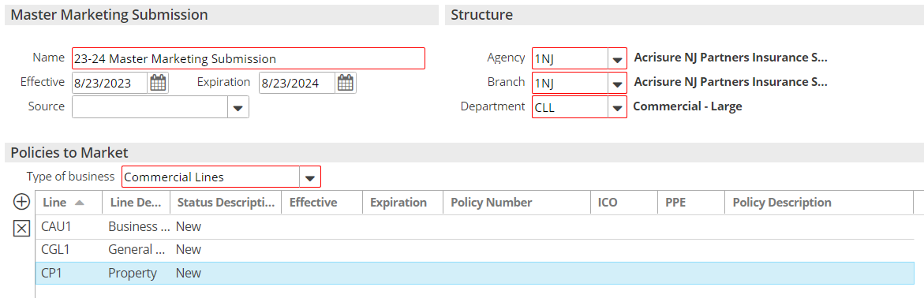

1. Add policies to the submission by clicking the **ADD** button under Policies to Market
2. **Add New Line**—Create new policy(ies) for marketing
3. Click DETAIL
4. Close the **AMMK** Activity - Finish
5. Enter policy detail by clicking each line in the navigation panel and completing each of the screens to fill in detail in the ACORD apps (be sure to add detail to the Commercial AP/ACORD 125 first)
6. Click on Submission Detail area from the Navigation Panel and click the **ATTACHMENTS** Tab and drag & drop all attachments to be included in the submission

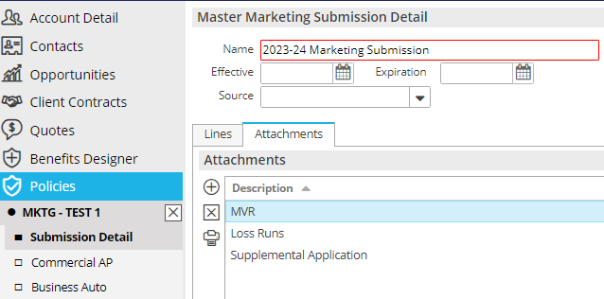

1. When finished, close Submission from the navigation panel (X)

### Add QNEW (New Business) or QREW (Renewal) Activity

1. From the **Policies Marketed** list view, highlight the Master Submission
2. Click the **NEW** button at the top in the blue bar; select **Activity** (or press F9)
3. Click **Continue**
4. Code = **QNEW or QREW**
5. Leave OPEN; add notes
6. Click **Finish**

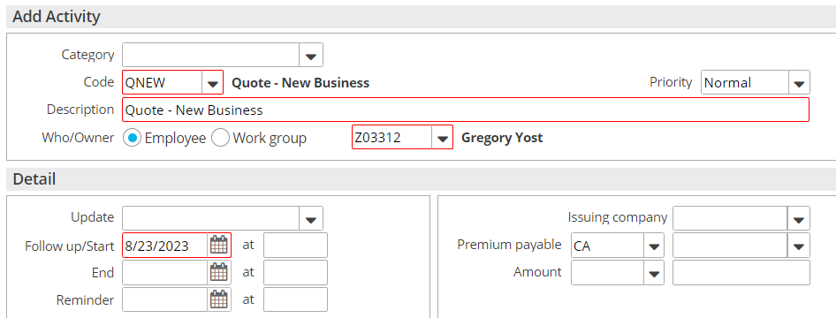

**Create a separate QNEW/QREW for each market/carrier/broker. Update the Premium Payable field in the activity with the carrier/broker.**

### Send Applications to Carriers

#### Save & Submit ACORD Applications

1. Right click on the Master Marketing Submission created above
2. Select **Review Application**
3. Select the “Master Marketing Submission” radio button; click **Continue**
4. Click the **Organization Contact** tab and verify/update the agency address
5. Click the **Distribution** tab
6. Under **Delivery Options** select **“Attach Without Distributing”**
7. Click **Finish**
8. With the submission highlighted, click **ACCESS >** **Attachments**, **right click** on the ACORD, and select **Send Via Email** if emailing to the underwriter
9. If quoting online, add notes to the Open **QNEW** or **QREW** Activity.

#### Attach quote-related documents to QNEW or QREW

Be sure to attach all emails, documents, applications, etc. tothe **QNEW** or **QREW** activity

1. Drag & drop onto the **QNEW** **or QREW** activity
2. Select the **Marketing** Folder
3. Click Finish on the **Attach to** screen

### Carrier Responses Received

1. Record carrier responses by adding NOTES in the **QNEW** **or QREW** activity.
   1. Right click on the **QNEW** **or QREW** activity
   2. Select Add Note
   3. Enter detailed note



1. Drag & Drop Carrier emails to the **QNEW or QREW** Activity

### Carrier Selected for Binding

1. When a carrier is selected for **binding**, close the corresponding **QNEW or QREW** as **Successful** and add notes.

***Please note, if no carrier is selected for Binding, close the corresponding QNEW or QREW as Unsuccessful, choose the reason and add notes. No further steps needed.***

#### Move Binding Carrier Submission to Current Policies

You must follow these steps in order**:**

1. Right click the Master Submission and select **Create Carrier Submission**
   1. Premium Payable = select the binding carrier
   2. Submission Status = Completed
   3. Click Finish
2. Right click the Master Submission and select **Update Stage to Entered/Submitted**

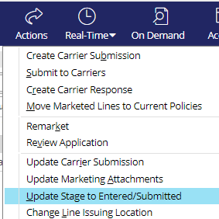

* + Click Finish

1. Right click the submission and select **Create Carrier Response**
   * Description = Quoted
   * Date Received = current date
   * Carrier Response = Quote
   * Enter Response Line Premium, carrier commission rate and click Calculate
   * Add Issuing company if known
   * Click Finish

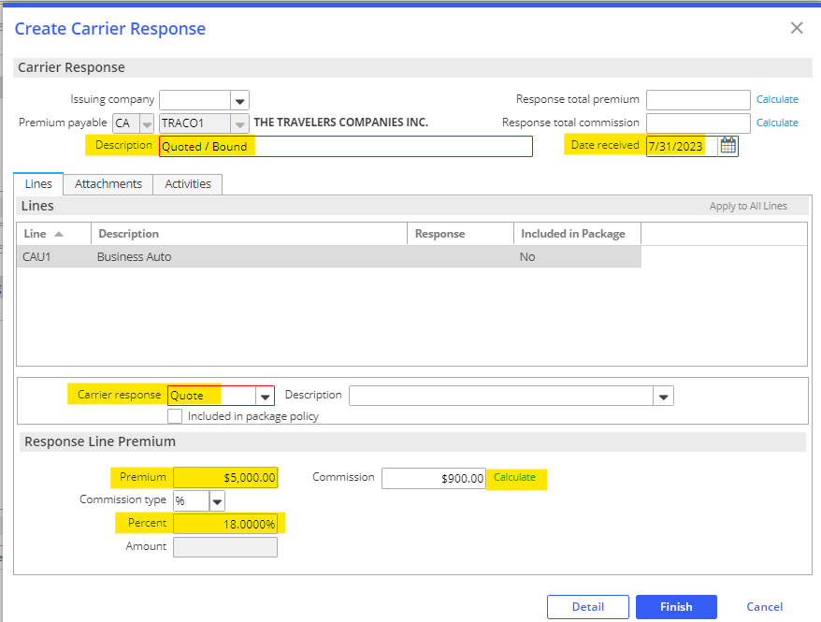

* + On the popup, select **Yes** Perform Action and select **Move Marketed Lines to Current Policies**

**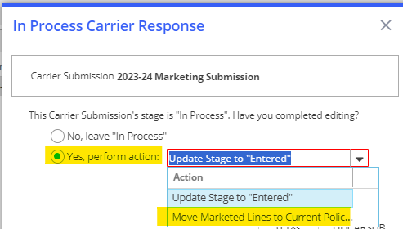**

***Policies Tab****:*

1. Select **Add new Policy for new business or renew existing policy for renewal business**
2. Enter Policy Line, Description, Effective & Expiration Dates
3. Update Stage to: Submitted or In Process if policy detail edits are needed
4. Select Contracted policy

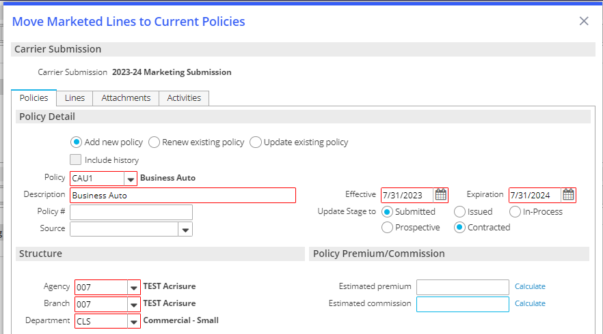

***Lines Tab:***

1. Select the lines you want to add to the new policy, renewal, or existing policy
2. Select **Add to this policy** - Adds the line to the policy added under the Policies tab

* Keep in mind that the choices are made here affect only the highlighted line
* Use **Apply to All Lines** if the choices apply to all lines and not just the highlighted line.

1. Under the LINE tab, select Status = NEW; enter Issuing Co (writing co); enter carrier commission rate.

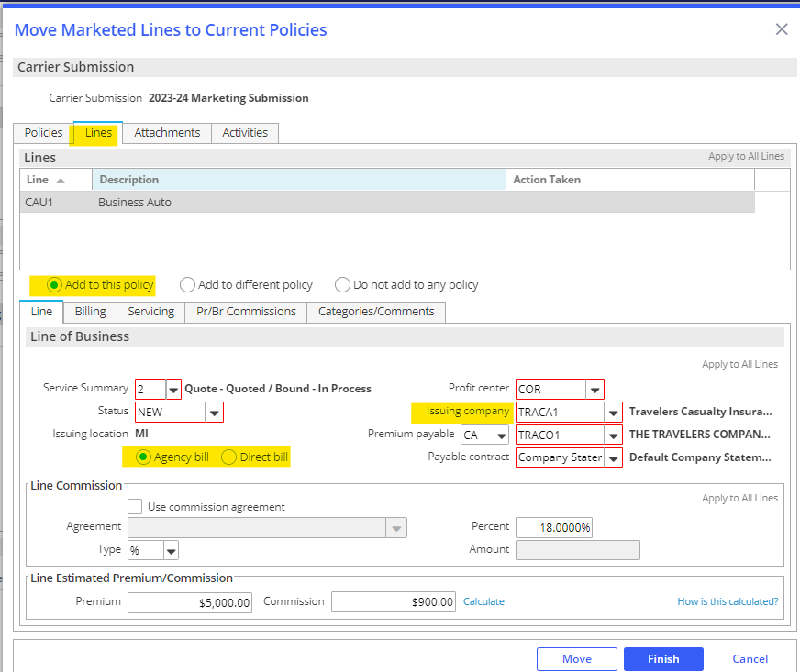

1. Click the **SERVICING** tab – verify the employees in each servicing role

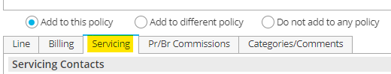

1. Click the **PR/BR COMMISSIONS** tab

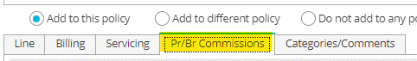

* + Click the ADD button to add the producer who will be paid commission on this policy, if applicable
  + Producer Commission will default
  + Production credit should be 100%

1. When finished, click **MOVE**

* Update Submission status to Completed; click **Finish**

1. **BND1** Activity – Bind Policy via Master Marketing
   * Leave open for receipt of policy
   * Add Notes
2. Change Policy view from MARKETED to CURRENT

### Policy Received from Carrier

1. Drag & Drop the policy dec to the appropriate **Policy** in the client’s account
2. Issue the Policy in Epic:
   * Highlight the policy
   * Click ACTIONS > Issue/Not Issue Policy and **Issue**
   * Verify Policy #, Effective/Expiration Dates, and Policy Status (NEW)
   * Click the **Close Open Activities** tab and close the open **BND1** activity as Successful and add final note
   * Click FINISH

## JA.2 Marketing Module (Full Version)

### Add Master Marketing Submission

|  |
| --- |
| 1. Click Policy from Client’s account 2. Change policy view from Current to Marketed 3. Click the ADD button 4. Enter a name for the Submission (i.e., Master Submission 2017-2018) 5. Enter required information (Department & type of business) 6. Add policies to the submission by clicking the **ADD** button under Policies to Market 7. **Add New Line**—Create new policy(ies) for marketing 8. **Add Existing Line—**Select from existing policies. Check all policies you want to market. **Include ALL lines of business you wish to market whether you send to a particular carrier or not.** 9. Click DETAIL 10. **Activity** = **AMMK -**Defaults Open for 3 days; click Finish 11. Enter policy detail by clicking each line in the navigation panel and completing each of the screens   When finished, close Submission from the navigation panel (X) |

### Create Carrier Submission

|  |
| --- |
| 1. Select the appropriate Master Marketing Submission 2. Click **ACTIONS** > **Create Carrier Submission** 3. Enter the PPE (Premium Payable) Carrier (CA) or Broker (BR) name 4. Update carrier submission description 5. Check each line to submit to the specific carrier 6. Enter the requested premium/commission (if desired) 7. Click the Attachments tab  * Uncheck attachments that are not needed for this carrier * Click the ADD button to attach additional documents, if needed  1. Click the ADD button to add additional carriers 2. Click Finish |

### Submit to Carriers

|  |
| --- |
| 1. Select the appropriate master marketing submission 2. Click **ACTIONS** > **Submit to Carriers** 3. Click Continue 4. Create one activity per Carrier Submission 5. Place a checkmark beside each carrier you want to send a submission to 6. Highlight the first carrier and complete all tabs for that carrier 7. Review attachments and ADD additional attachments if needed 8. Distribution—select Print, Email or Fax and complete the details 9. Highlight the next carrier (if applicable) and complete all tabs as above 10. Preview if desired; Click Finish 11. **Activity** = **SCAS** defaults to open for 3 weeks; click Finish |

### Create Carrier Response

|  |
| --- |
| 1. Select the appropriate Master Marketing Submission 2. Click **ACTIONS** > **Create Carrier Response** 3. Enter a Description for the Response (i.e., Quoted $1,000; declined due to claims, etc.) 4. Enter Date Received 5. Click the Dropdown for Carrier Response and select Decline, Not Received, or Quote. 6. If you submitted multiple lines and the carrier response applies to all lines, click “Apply to All Lines” in the gray bar, right 7. Click Detail 8. Update policy lines as needed 9. Close policy from the Navigation Panel (X) 10. If quoted, update stage: “Yes Perform Action” - choose **Update Stage to Entered** if still waiting on other carrier responses; **or Move Marketed Lines to Current** if the client has accepted carrier’s quote. |

### Attach Quote-Related Documents to SCAS Activity

|  |
| --- |
| 1. Be sure to attach all emails, documents, applications, etc. to **the specific carrier SCAS activity** 2. Drag & drop onto the **SCAS** activity 3. Select the **Marketing** Folder 4. Click Finish on the **Attach to** screen |

### Bind/Accept Quote

|  |
| --- |
| 1. When a carrier is selected for binding, leave that carrier’s **SCAS** activity Open until you receive the policy dec from the carrier 2. Close All other **SCAS** activities as Unsuccessful and select reason from the dropdown list 3. Add notes as to why not binding with that specific carrier. |

### Move Marketed Lines to Current Policies

|  |
| --- |
| 1. If you chose “Move Marketed Lines to Current” in STEP 3, continue to the Policies tab (below); otherwise, highlight the submission you are moving, and click **ACTIONS > Move Marketed Lines to Current**  * ***Policies Tab*:** * Select Add new Policy if this is a new policy/new business * Select Renew Existing Policy if you created the Marketing Submission from a Renewal * Select Update Existing Policy if you are adding policy lines to an existing policy. * Enter Policy Line, Description, Effective & Expiration Dates * Update Stage to: Submitted, Issued, or In Process * Select Prospective or Contracted policy * ***Lines Tab*:** * Select the lines you want to add to the new policy, renewal, or existing policy * Select:   + Add to this policy - Adds the line to the policy added under the Policies tab   + Add to different policy   + Do not add to any policy * Keep in mind that the choices you make here affect only the line highlighted. * Use Apply to All Lines if the choices apply to all lines and not just the highlighted line. * You have three opportunities to Apply to All Lines in this section * ***Attachments Tab*:**   + If Attachments were added to your Master Marketing Submission, they would show here.   + Check the attachments you need to move with this Policy. * ***Activities Tab:*** * You may close any open activities that exist for this Carrier Submission.  1. When finished, click **MOVE** 2. Update Submission status to **Completed**; click Finish 3. Change Policy view from MARKETED to CURRENT |

## JA.3 Accounting Processes

|  |
| --- |
| With the move to the platform, transactions and other accounting related functions have transitioned to the accounting team.  The Operations Excellence team has provided stand-alone Accounting Activities Guide and Workflows that are available on the [New Jersey Platform SharePoint.](https://acrisure.sharepoint.com/:w:/s/ACR-ABSAccountingTeam/ESAdZgcBwPdJt0_n5-hNILkBueeqZpQWrGK6rg54rr9l7g?e=4LVSdM) |

## JA.4 Renewal Manager

### Renewal Stages

***Details in the Renewals Manager view are related to the expiring policy.***

|  |  |
| --- | --- |
| **Stage Description** | **How it functions** |
| **Renewal Not Started** | Tied to the Event: **Policy Created** (display policies with this stage in the RM "**0**" days after expiration) |
| **Pre-Renewal In-Process** | Manual - (display policies with this stage in the RM "**30**" days after expiration) |
| **Submitted For Quote** | Manual - (display policies with this stage in the RM "**30**" days after expiration) |
| **Quote Received** | Manual - (display policies with this stage in the RM to "**30**" days after expiration) |
| **Proposed** | Manual - (display policies with this stage in the RM to "**30**" days after expiration) |
| **Renewal In-Process** | Tied to the event: **Policy Renewed** (display policies with this stage in the RM "**30**" days after expiration) |
| **Renewed** | Manual - (display policies with this stage in the RM "**0**" days after expiration) |
| **Did Not Renew** | Tied to the event: **Policy Cancelled** (display policies with this stage in the RM "**0**" days after expiration) |

### Renewal Events

#### Policy Created

This Event is responsible for a new policy as well as a renewed policy to be given the Stage Renewal Not Started. This is the Stage that begins the renewal effort. Policies coming up for renewal will show in the RM, in advance of the renewal date with the Stage Renewal Not Started, according to the time frame assigned to the policy type.

* 120 days for commercial lines policy types
* 60 days for personal lines policy types
* 90 days for employee benefits policy types

#### Policy Renewed

This Event is tied to the Actions>Renew process. When the expiring policy (the current term…the one you are working on renewing) is renewed (via Actions>Renew), the expiring policy (i.e., the current term…the one you are working on renewing) will be given the Stage Renewal In-Process. The renewed policy (i.e., the policy created through the Actions>Renew process) will not show in the RM but will show in the Policy list view (e.g., Policies – Current/Renewed). The renewed policy will be given the Stage Renewal Not Started. This Stage should remain as is until you are ready to work on the renewal of that policy the following year. The renewed policy (i.e., the one created via Actions>Renew) will need to be Issued as normal. The Stage given to the expiring policy (i.e., the current term…the one you are working on renewing) will need to be changed, by the user, to Renewed once the renewal policy has been Issued. This Stage, Renewed, will be the final Stage given to the expiring policy in the RM. An expiring policy with the Stage Renewed will drop from the RM view on the expiration day.

#### Policy Cancelled

This Event is tied to the Actions>Cancel>Issued process. The Stage shown on a policy cancelled via the Actions>Cancel>Issued process will be Did Not Renew. Note: if the policy is reinstated, the Stage will automatically revert to the Stage it was assigned before it was cancelled.

### Renewal Manager Workflows

#### View Renewals

1. From **HOME** screen select **Renewals Manager** from Navigation Bar

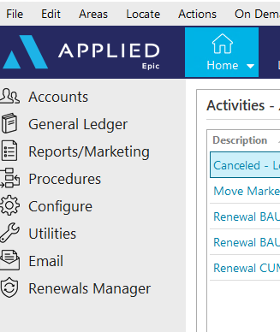

1. Assigned Servicers accounts will be displayed with a **Renewal Not Started** Renewal Stage

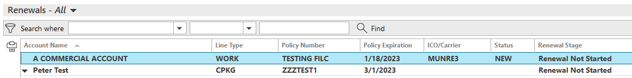

* **Personal Lines**: 60 Days prior to expiration
* **Commercial Lines**: 120 Days prior to expiration
* **Employee Benefits**: 90 Days prior to expiration

1. Click once on renewal to select:



* **Go to Policy** – Takes you directly into the policy under the client’s account
* **Renew** – Starts the renewal process from the client’s account
* **Marketing Submission** – Starts a marketing submission from the client’s account
* **Update Renewal Stage** – Allows you to manually update the renewal stage
* **Market Appetite** – Launches IVANS Market Appetite with list of possible markets

#### Renew Policy

1. Select **Renew** then refer to the **Renewal Process**/**Non-Downloaded Policies** section in your Workflows Document



1. Once renewal is started, the Renewal Stage will change to **Renewal In Process**
2. Manually update the stage as needed:

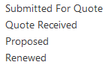

#### Marketing Submission

1. Select **Marketing Submission** then refer to the **Marketing Module** section in your Workflows Document



1. The Renewal Stage will NOT automatically update as you work through the Marketing Module. You must update the Renewal Stage manually by selecting **Update Renewal Stage.**



#### Cancelled/ Non-Renewed Policies

**Cancelled Policies:**

1. Refer to [**Cancellations**](#_Cancel_Policy_Workflow) section of your Workflows Document
2. Once **Cancellation** has been issued, the Renewals Manager Stage will automatically be updated to **DID NOT RENEW** and will drop off your Renewals Manger list

**Non-Renewed policies:**

1. Refer to [**Policy Not Renewed**](#_Policy_Not_Renewed) section of your Workflows Document
2. The Renewal Stage will NOT automatically update after you have Non-Renewed the Policy. You must update the Renewal Stage manually by selecting **DID NOT RENEW** from **Update Renewal Stage**. This policy will NOT drop off the Renewals Manager list, but will stay for one day AFTER expiration

## JA.5 Proofs of Insurance in Epic

### Auto ID Cards

1. Account Manager/CSR to send request via email to \*\*NJ Auto ID Request\*\*
2. CL Team to monitor inbos and work requests in the order they are received.
3. To Issue Auto ID Card in Epic:
4. Locate client account and go to the policy tab
5. Select appropriate Auto policy
6. ACTIONS > Issue Auto ID Card
7. Highlight the appropriate vehicle—make sure there’s a Y under the Issue Column or Click Select to Issue if not

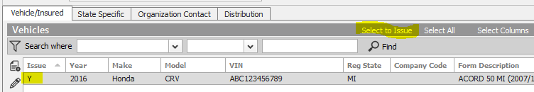

1. Click the Distribution Tab
2. Select Contact (use magnifying glass to locate)
3. Select Via (Print, Email, Fax) and enter additional details
4. Click Finish—AUID Activity generates, and defaults closed. Drag and drop the request email and the delivery email to the closed AUID activity.

## JA.6 CSR24 Workflow

|  |
| --- |
| Access to the CSR24 Workflow Manual can be found here:  [CSR24 Workflow Manual v4.17.25.docx](https://acrisure.sharepoint.com/:w:/r/sites/AcriWorld/Shared%20Documents/Enterprise_Solutions_Center/Platforms/New_Jersey/Epic,%20CSR24%20%26%20Indio%20Resources/CSR24/CSR24%20Workflow%20Manual%20v4.17.25.docx?d=wfd753bbb4b3e4121a273bbcb02428ad2&csf=1&web=1&e=E4NVJq) |

## JA.7 DocuSign Integration

**From Attachments in the Client’s account**:

1. Right-click the attachment and select **Send to eSignature**

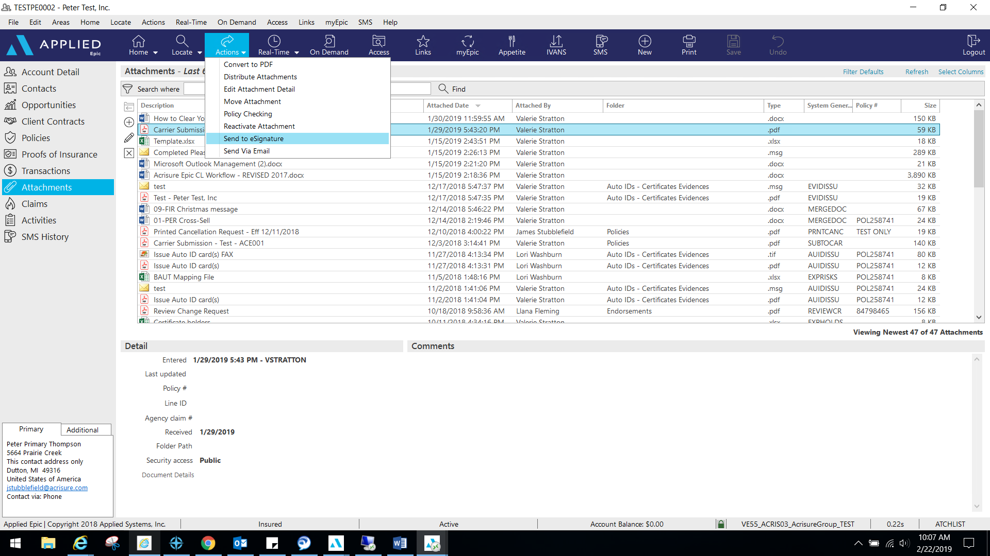

1. 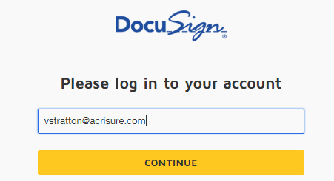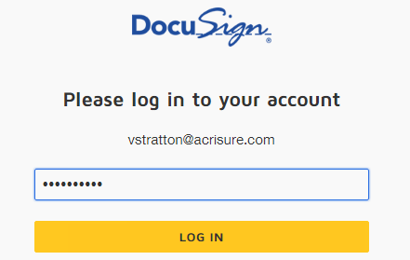Log into **DocuSign** using your email address and password.
2. Allow DocuSign permission to integrate with Epic.

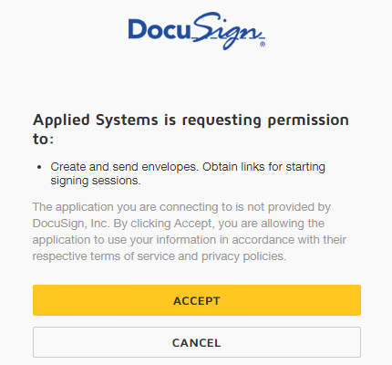

1. Select an Epic Contact; click the TO button

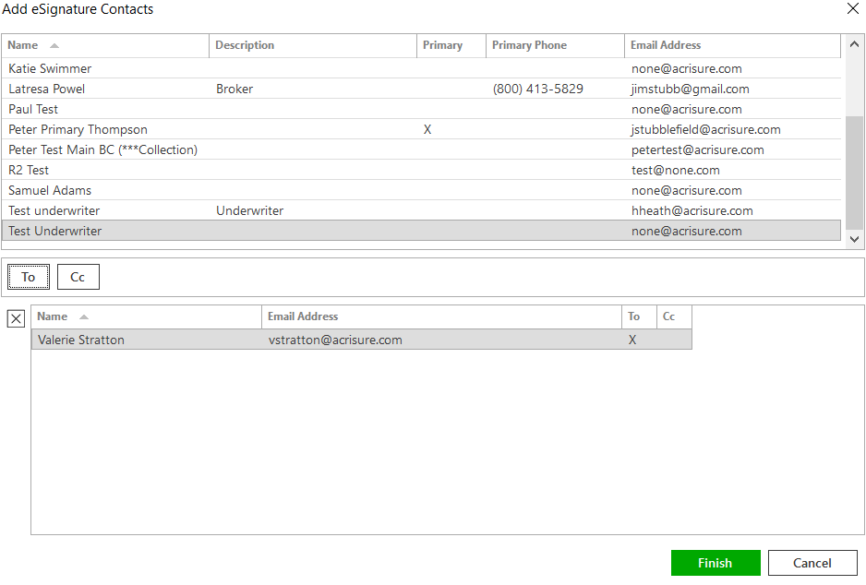

1. Please wait while Epic directs the document to DocuSign for signatures fields.
2. Add appropriate fields for signature, date, text, etc. by dragging and dropping onto the document.

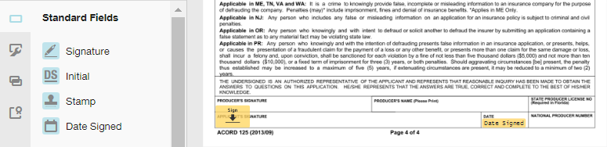

1. If you are using a template, you will need to remove the extra recipient. Actions>Edit Recipient.  
   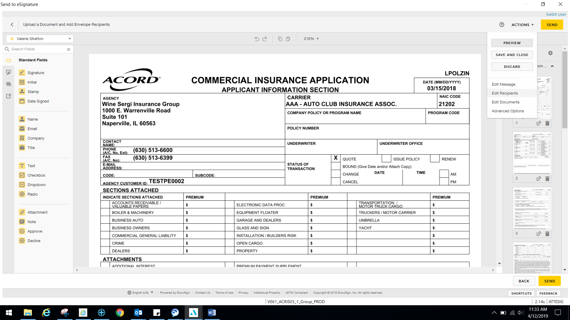
2. Once finished, select Actions>Edit Message.

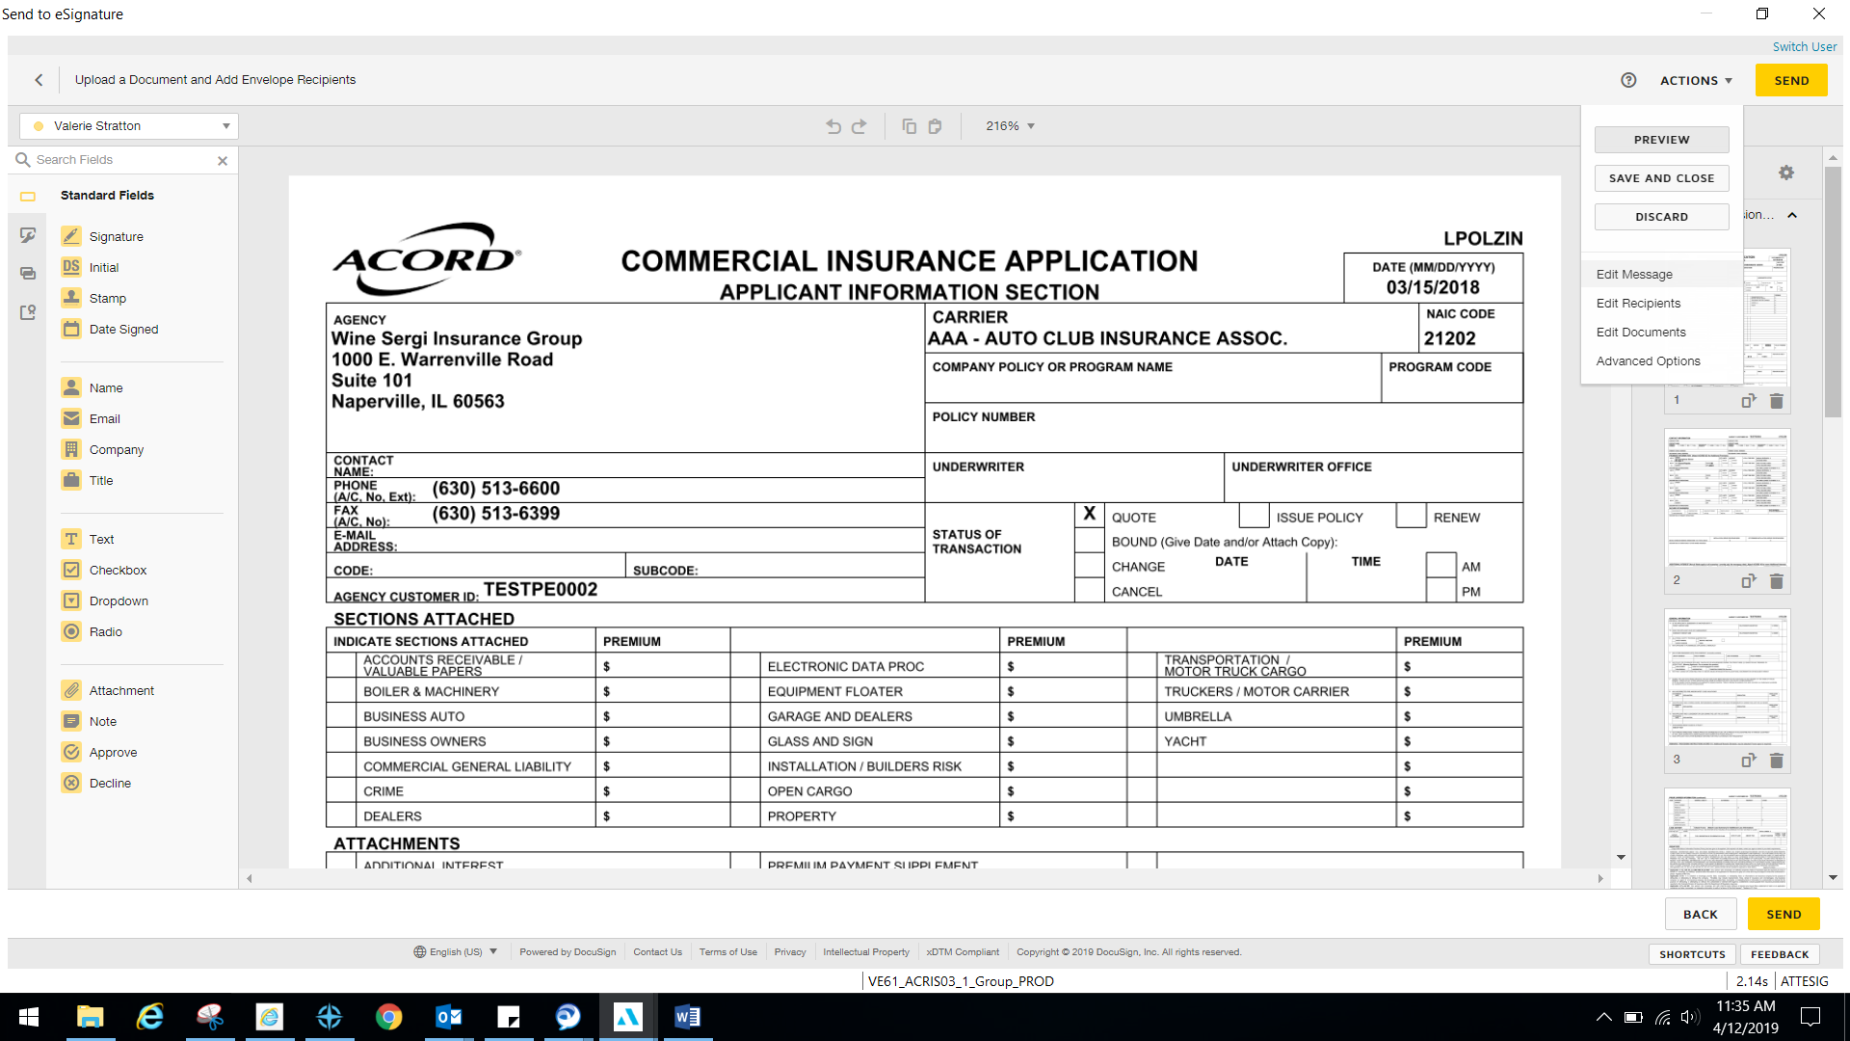

1. Edit the email subject line and personalized message to client and select Done.

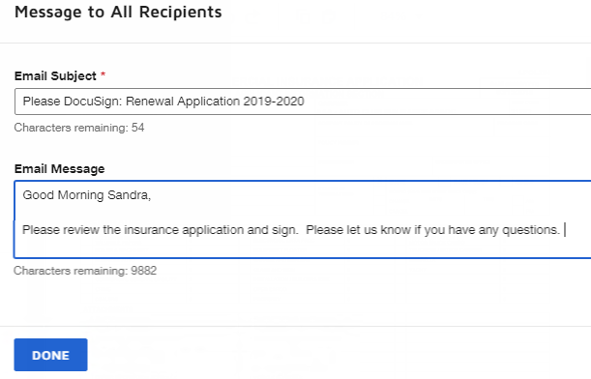

1. Select Send in the top right or bottom right corner when finished.

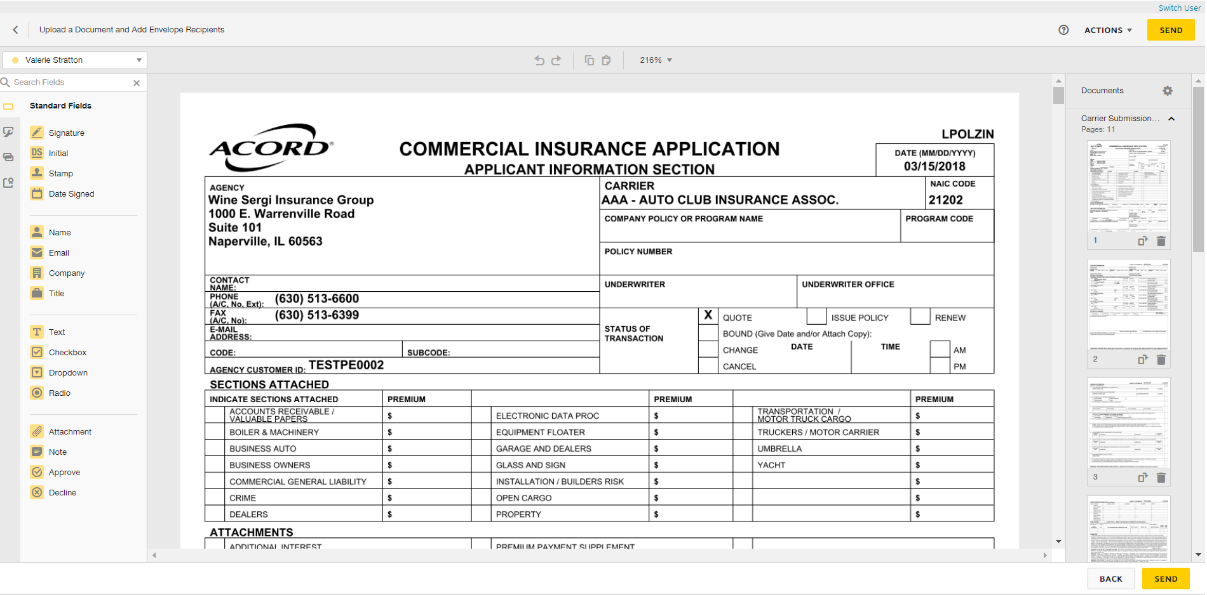

1. You will be redirected to your DocuSign account to manage your envelopes. Close out when finished.
2. **ESIG** will be the automatic activity generated once finished and will automatically remain open for follow up. Close **ESIG** as successful if there is another open activity related to this process.

## JA.8 Import and Export Risks

|  |
| --- |
| Import/Export can be performed for the following:   * Locations * Drivers * Named Insureds * Vehicles * Scheduled Equipment |

### STEP 1: Create a Mapping File

|  |
| --- |
| A correctly formatted mapping file is needed to ensure that data imports into the correct fields in Epic. Before importing, create a blank mapping file (spreadsheet)   1. Highlight appropriate policy 2. Click ACTIONS > Export Risks 3. Select Type of Import – drivers, vehicles, etc. 4. Select Mapping File 5. Enter a file name 6. Check “Disable Delivery Options” 7. Check “Send as Blank Template”   A screenshot of a computer  Description automatically generated   1. Click Continue 2. Click Export; Click YES 3. Click Attachments and locate the mapping file. The mapping file can then be used to paste details into a file for the initial import, proceed to next step. |

### STEP 2: Enter data on the Mapping File

|  |
| --- |
| **Template file MUST remain as is. Do not delete any columns or the Import will not work.**   1. Copy and paste the information in each column. If there is no data for a particular column, leave it blank. 2. Click File > Save As and rename the Import File saving it to your Desktop |

### Exporting Risks out of Epic

|  |
| --- |
| For risks that are already in Epic, use the export risk function to generate a spreadsheet that the client can update at renewal. Those risks can then be imported back into Epic.     1. Highlight appropriate policy 2. Click ACTIONS > Export Risks 3. Select Type of Import – drivers, vehicles, etc. 4. Select Mapping File 5. Enter a file name – ex. 2024 Driver List 6. Check “Disable Delivery Options” or complete the email information to deliver out of Epic to the client 7. Click Continue 8. The next screen will show all risks to be exported, if that list looks correct, click Export > then click YES 9. The file will be in the attachments. Email to client for review and update. Completed spreadsheet should be saved on your desktop for importing into Epic |

### Importing Risks into Epic

|  |
| --- |
| Policy status MUST be “In Process” in order for Import Risks to work. If the policy is not “In Process”, click **ACTIONS** > Endorse/Revise Existing Lines and choose the **CHGI** (Internal Policy Change) activity code. After the Import is complete, **ACTIONS** > Issue/Not Issue Endorsement and select Issue.   1. Highlight appropriate policy 2. Click ACTIONS > Import Risks 3. Click the ADD button to add the source file 4. Select Risk Type 5. Select an Importing Option:    1. Import & Update – items with no match will be added    2. Import & Replace – imported list will replace ALL existing items. Coverage information will be lost    3. Import, Update & Remove – items with no match will have the option to be deleted from the policy 6. Select File to Import – click the magnifying glass to locate the file you created in Step 2. 7. Choose “Existing File” if the file is located outside of Epic (i.e., Desktop); click Continue 8. Browse, select file, click Open 9. Change Description if needed 10. Click **Finish** 11. Click **PROCESS**   A screenshot of a computer  Description automatically generated   1. A close up of a screen     Description automatically generatedPay attention to the **STATUS**; click Refresh. 2. When status = **Processed**, click CREATE 3. Pay attention to the STATUS; click Refresh 4. When status = **Created**, click PREVIEW 5. Import list will display 6. Click **IMPORT** 7. Click **YES** 8. Pay attention to Status; click Refresh 9. When import file disappears, the import was successful 10. Close window (red X top right) 11. Double click policy to view imported data 12. Close policy in Navigation Panel (gray X) 13. Select “Yes Perform Action” and choose “Issue/Not Issue Endorsement” 14. Click Finish |

### Import Errors

|  |
| --- |
| Sometimes data does not import correctly. When this happens, the following messages appears. Follow the steps to review and update the errors.  A screenshot of a computer error  Description automatically generated  Epic will save a separate Excel file containing all the rows that failed.   1. Locate the Error File in Attachments 2. Fix the issues 3. File > Save As and save the updated file to your Desktop 4. Run the Import again |

## JA.9 Creating a Proposal or Summary in Epic

### General Information

|  |
| --- |
| Epic has been configured with templates to allow users to generate Platform branded Proposal and Summary that can be used to present to clients when marketing coverage for new or renewal business. The Summary template is accessed using On Demand>Proposal – Do not use On Demand>Summary of Insurance.    **The following are highlights and pointers to consider:**   * The same proposal group works from either the Current/Future lines or the Marketed lines (at the carrier response stage) * Each line of business is configured to pull the following four (4) areas from the Epic policy details into the Line of Business page on the Proposal:   + Additional Coverages   + Forms & Endorsements   + Remarks (only when the Print on form is checked)   + Additional Interest * When using the Summary Group, users will have to associate the Line of business to both the Premium Summary pages and the Detail pages for each selected policy. This will ensure that the policies will appear on the premium summary page as well as the policy detail pages.      * Remember to enable Macros when the Word document generates as this is how the data merges into the document. * The overall formatting of each page of the Proposal and Summary templates has been designed to meet the legal specifications of Acrisure and to meet general needs of most of the users. The word document will need to be reviewed carefully as some data may need to be manually updated. Tables and data fields with no information should be updated or deleted and spacing should be adjusted to provide a professional look and feel. |

### How to Generate a Proposal

|  |
| --- |
| 1. Within the Client Account navigate to the Policies tab.  3. Click on a policy (or package header)   * 1. If creating a proposal for Marketed, change the view from Current/Renew to Marketed and then select the Submission.   4. On the Option Bar/Menu (top navy bar) click On Demand>Proposal.  5. You will be prompted to add an activity, choose **PROP** for a Proposal or **SUMM** for a Summary    **The following represents the Add Proposal box. Refer to the screen shot below and the corresponding numbers with the following steps:**    See Notes  1. Add/Remove the policies that will need to be included in the proposal.   * 1. Click on the ADD button and choose from either:      + the available current/renewed policies, if generating from the current/renew policies view      + the available lines being in the marketing submission, if generating from the marketing area   \* You do not need to reposition the LOBs on the top half of the proposal box.  2. Pick the Proposal Group. The NJ Platform has the following options and each one has preselected pages within the group. Choose the option that best suits your needs.   * 1. 1. Acrisure Standard Proposal   2. 1. CL Acrisure Summary of Insurance   3. 1. PL Acrisure Summary of Insurance   3. The Proposal Templates/Proposal Documents box will display all the preselected pages available based on the selected Proposal Group. This list must be reviewed, and pages deleted or rearranged based on guidelines determined by your leadership.   * 1. A cover page is required and must be in the top position   2. Associate a Line of Business to the Location Summary page to pull premises data   4. Individual Contacts are from the Account Contacts tab and will default with the Primary contact. Contacts added here will pull through to the Authorized Persons page.  **Notes:**  1. Before pressing Finish, you can add/move/delete pages, using the buttons on the left.  2. If you have multiple LOB of the same type, extras will drop to the bottom of the list. Be sure to reorder them before pressing Finish.  3. The premium summary page must appear after all the LOBs. Note: after merging, it can be moved.  4. LOBs without an associated Line will be suppressed by default. Uncheck the box next to Suppress blank templates to bring in the page even if there is not a LOB connected yet (e.g. you want to offer Cyber but it is not included on your account yet). |

## JA 10: Epic Proofs of Insurance

### Certificate Processing in Epic

#### Step 1: Add Master Certificate Template

1. Locate Client Account
2. Highlight the client on the **Locate** screen and click **Proof of Insurance** on the left navigation panel
3. Click **Certificates**
4. Under the Certificates – Liability Section, click the **Add** button

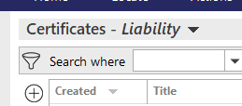

1. Select the ACORD type and enter a title (i.e. 2022-23 Master Certificate)

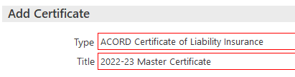

1. Click **DETAIL**, bottom right
2. Verify the Insured’s name and address
3. On the left navigation panel click **General Liability**
4. Click the ADD button under **Available Templates**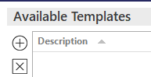
5. Click the dropdown in the **Line of Business** field and select the current General Liability policy
6. Enter a **Description** (i.e.22-23 General Liability)
7. Check the **Default Template** box
8. The limits will pull in from the policy detail. If not, go back to the policy detail enter the coverage and limits detail first before creating the certificate templates.

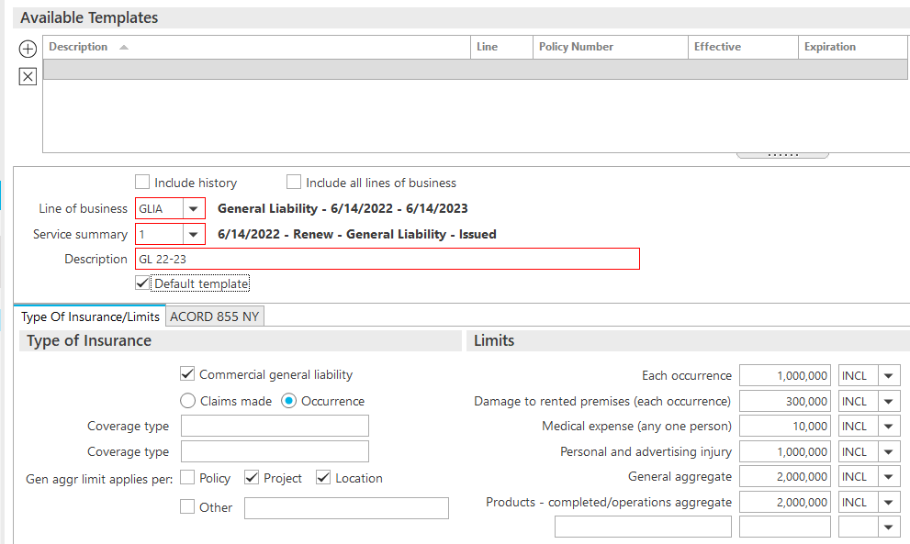

1. Repeat the process for the Auto Liability, Excess Umbrella Liability, Work Comp Liability, etc.

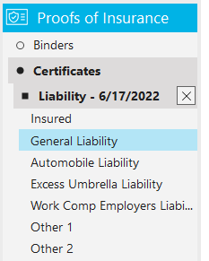

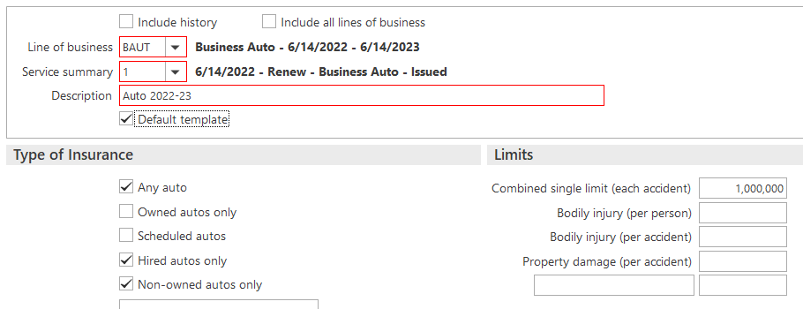

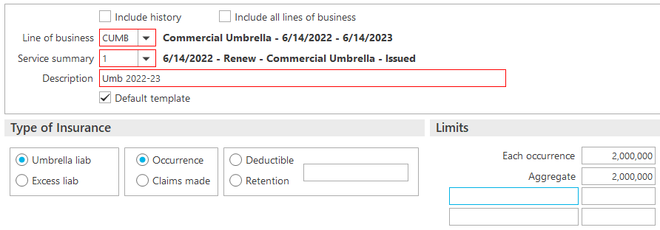

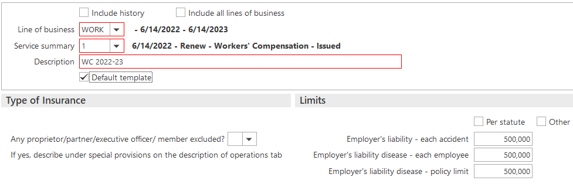

1. Under **Descriptions of Operations** in the navigation panel enter any language that pertains to **ALL** certificate holders. If the Description of Operations is holder specific, you will enter the language at the Holder level.

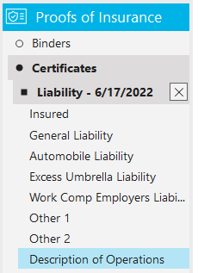

1. Under **Attachments** in the navigation panel enter any certificate attachments that pertain to **ALL** certificate holders If attachments are holder specific, you will add them at the holder level.

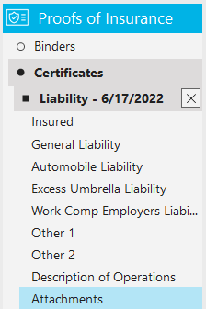

#### Step 2: Add Certificate Holders

1. Select **Holders**, in the left navigation panel

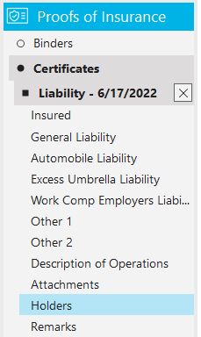

1. If the **certificate holders** exist on another Certificate Master in this account, copy them by clicking the **Copy from Another Certificate Link** at the top right of the screen.  
   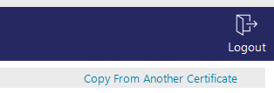
   1. Select the Master you wish to copy the holders from and select the holders you wish to copy. You can default the holder description of operations and attachments that exist on the other master.

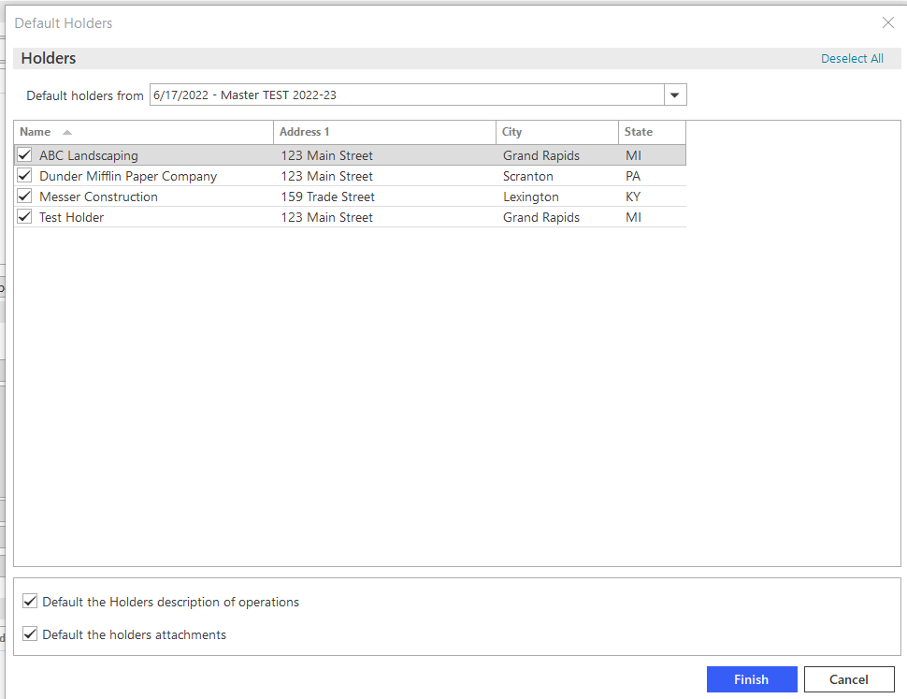

* 1. Click **Finish**

1. To add a **New Holder**, click the Add button under Holders

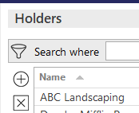

1. Enter the name, address, and choose a distribution method of the Certificate Holder. Templates will default.

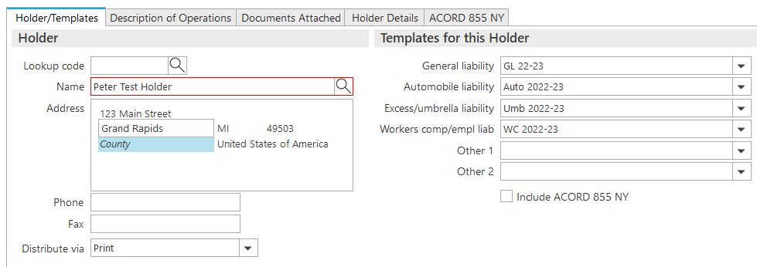

1. Click the **Description of Operations tab** and enter **holder specific** description of operations. If you add language to the summary field, be sure to check the box to Print Holder Summary so it will appear on the certificate. There is also room below this field to add more detailed information if needed.

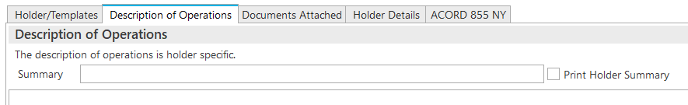

1. Click the **Documents Attached tab** to attach **holder specific** attachments, such as an Additional Insured coverage form.
2. Click the **Holder Details** **tab** and select the appropriate checkboxes as needed.
3. On the **Holder Details tab** Verify the **Named Insured**. If you need to add a different Named Insured, click the magnifying glass to select the appropriate Named Insured from the **Contacts** area of the client’s account.

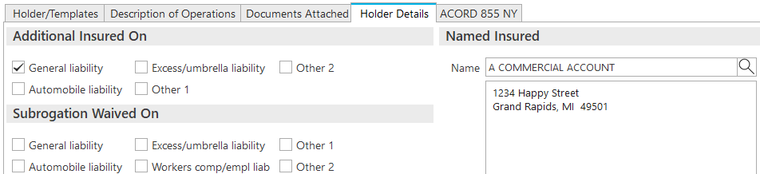

1. Once all fields are completed, close out using the **X** in the navigation panel

#### Step 3: Issue Certificate

1. From the **Certificates** list view, select the appropriate **Master** and **Holder**

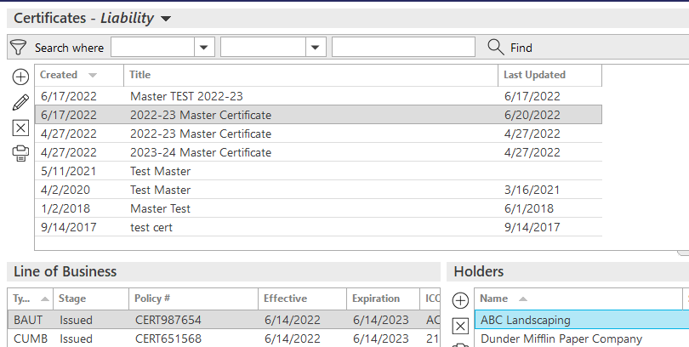

1. Click **ACTIONS > Issue Certificate** for multiple holders, or **Issue Single Holder** for one holder.

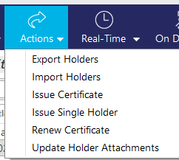

1. Enter an agency **Contact Name** (required) using the magnifying glass
2. Click the **Organization Contact tab** to verify the agency’s address and contact information
3. Click the **Holder Distribution** **tab**
   1. Under **Distribute to**: Uncheck the client name
   2. Check the Holder and click on the holder to highlight. The information showing beneath the Distribute To list pertains to the highlighted item.
   3. Choose a **scanned signature**. This is a required field.
   4. Enter **Delivery Options**. If emailing, subject is a required field. You can also cc and bcc the certificate.
4. Click **Download and Print** to preview the Certificate before sending.
5. Click **Finish**
6. A **CERT** Activity will be created and default to closed
7. Click **Finish**.
8. A copy of the Certificate is attached automatically in the client’s Attachments.

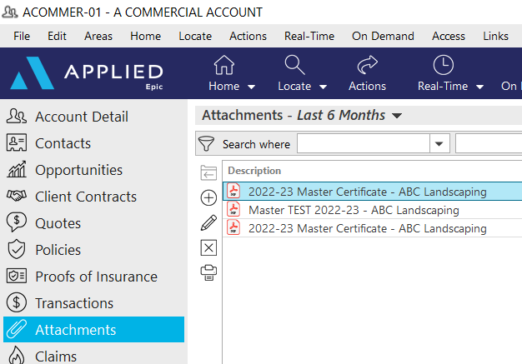

#### Renew Certificate

1. Click **Proofs of Insurance** from the left navigation panel
2. Highlight the certificate you want to renew
3. Choose **Actions>Renew Certificate**
4. Change the Title of your renewal certificate to the current year use the naming convention.
5. Select the Default boxes as appropriate for this renewal

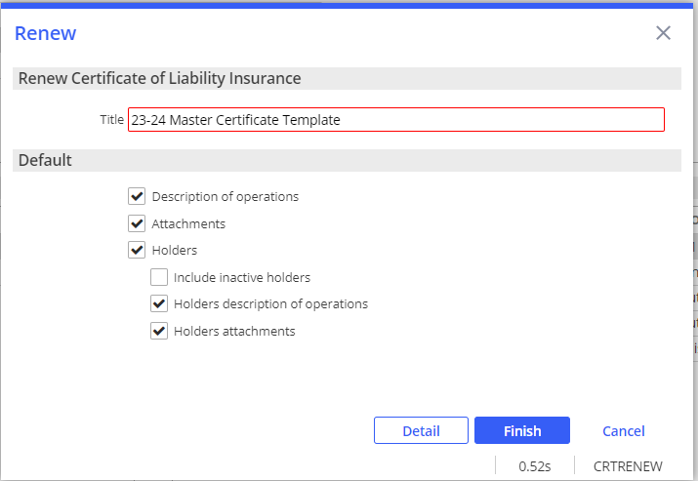

1. Choose **Detail**
2. Add any applicable notes to the system generated **RCER** activity
3. Choose **Finish**
4. Update the coverage tabs in the Navigation Panel to reflect the current year policies
5. Verify the holder information and select additional templates if needed
6. Choose **Actions>Issue certificate** to issue all renewal certificates (uncheck any that aren’t needed)
7. Choose **Finish** Certificates will attach to Epic in the attachments screen

### EPIC Binder

1. Locate Client Account
2. Highlight the client on the **Locate** screen and click **Proof of Insurance** on the left navigation panel
3. Click **Binder**
4. Click **Add**
5. Add Description of Binder
6. Highlight the policy you are issuing a binder for
7. Click **Detail**
8. Review each section of the binder in the left navigation panel

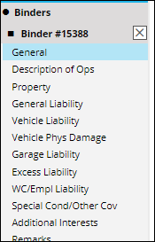

1. When completed, click **ACTIONS** > **Issue Binder**

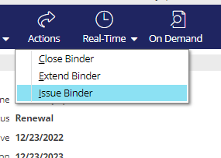

1. In the Issue Binder Pop up
   * Click the **Additional Interest Distribution Tab**
   * Select **Contact** (use magnifying glass to locate)
   * Select **Via** (Print, Email or Fax via Email) and enter details

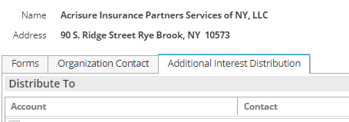

1. Click **Download and Print** to preview the Certificate before sending..
2. Click **Finish**
3. Click the X in the Navigation Panel to close out of the Binder
4. Add an activity, **BIND** and close successful
5. Click **Finish**

## JA. 11 Job Aid – Statement of Values

* + - 1. From the Client’s Account, Click the **Policies** from the left navigation panel
      2. Highlight the Property Policy
* *Policy HAS to be ‘In Process’ – if Policy is NOT ‘In Process’ follow* [*internal endorsement*](#_Process_Change_Request) *and select* ***CHGI*** *activity code)*
  + - 1. Double Click the Property Policy
      2. From the Navigational Panel, click the Commercial AP and select Premises

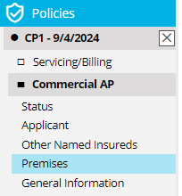

* + - 1. In the Premises area, click the plus sign to add a new location

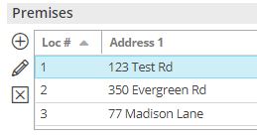

* + - 1. In the popup box, check the box for Blanket and in the address field, type “BLANKET”

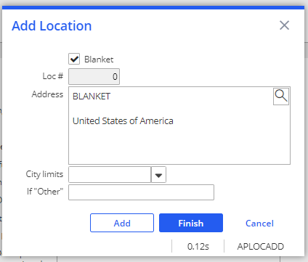

* + - 1. Click **Finish**
      2. In the left Navigational Panel, double click the Property Line
      3. Click **Premises** in the Navigational Panel
      4. Click the **+** under **Premises** to add the **Location 0**
      5. **Location 0** – Blanket will appear. Check the Box.
      6. Click **Finish**

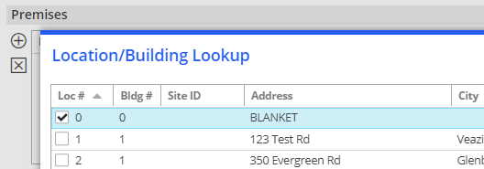

### Update Subjects of Insurance

* + - 1. From the Navigational Panel, click Subjects under the Property Line
      2. Enter all data for each location, i.e. Subject of Insurance, Description, Amount, Valuation, etc.
      3. Be sure to add a Cause of Loss and update the Coinsurance %, otherwise the values for each will show as $0 on Statement of Value.



* + - 1. Repeat for each location; highlight the location and fill in the details for the highlighted location at the bottom.

### Prepare Statement of Values

1. Click **Statement of Values** in the Navigation Panel
2. Click the plus sign under the Statement of Values Schedule tab
3. At the top, under the Statement of Values – ACORD 139 section, fill in all relevant information, i.e. Headquarters address, other coverages like earthquake and flood, coinsurance percent, applicable cause of loss and total value. ***NOTE: You will need to manually total the property values and enter the total in the Total Value Field***
4. Select all locations to be included in the Statement, check the box to include all property premises if applicable, then click **FINISH**



### Print Statement of Values

Click the PRINT button from the top blue options bar and select Statement of Values

Click the Distribution tab to select the distribution options (Print, Email, Fax) and enter all details

Click Download & Print to view the document before distributing Click FINISH